**MEMORIA DE CÁLCULO ESTRUCTURAL**

**MORELIA (FASE 2)**

**LOCALIDAD DE LA CAMPIÑA**

**MICHOACAN.**

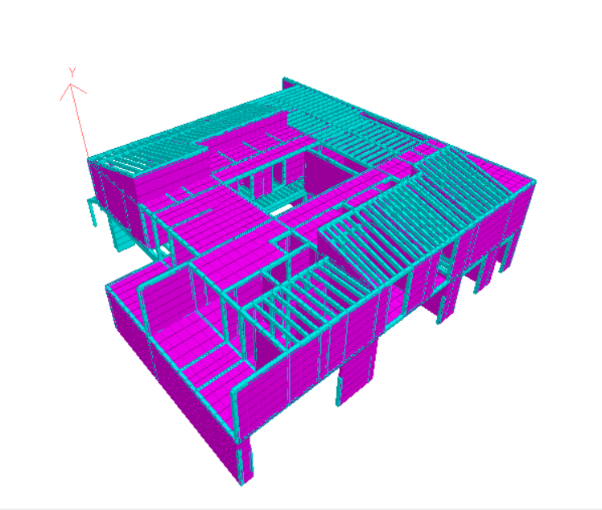

**AGOSTO 2021**

**CONTENIDO**

**INTRODUCCIÓN**

**REFERENCIAS**

**DESCRIPCIÓN DEL INMUEBLE CON REPORTE FOTOGRÁFICO**

**ANÁLISIS DE CARGAS**

**CÁLCULO DE PRESIONES DE VIENTO**

**ESPECTRO DE DISEÑO SÍSMICO**

**ANÁLISIS Y DISEÑO ESTRUCTURAL**

**CORRIDA DEL PROGRAMA DE ANÁLISIS**

**REPORTE FOTOGRÁFICO DE DISEÑO**

**REVISIÓN DE ELEMENTOS DE CONCRETO**

**REVISIÓN DE ELEMENTOS DE MADERA**

**INTRODUCCIÓN**

Se realiza la memoria de cálculo estructural para casa habitación ubicada en la localidad La Campiña, Pablo Galeana O las Galeras, 58341 Morelos, Mich.. Con las siguientes coordenadas 19.633173, -101.247084

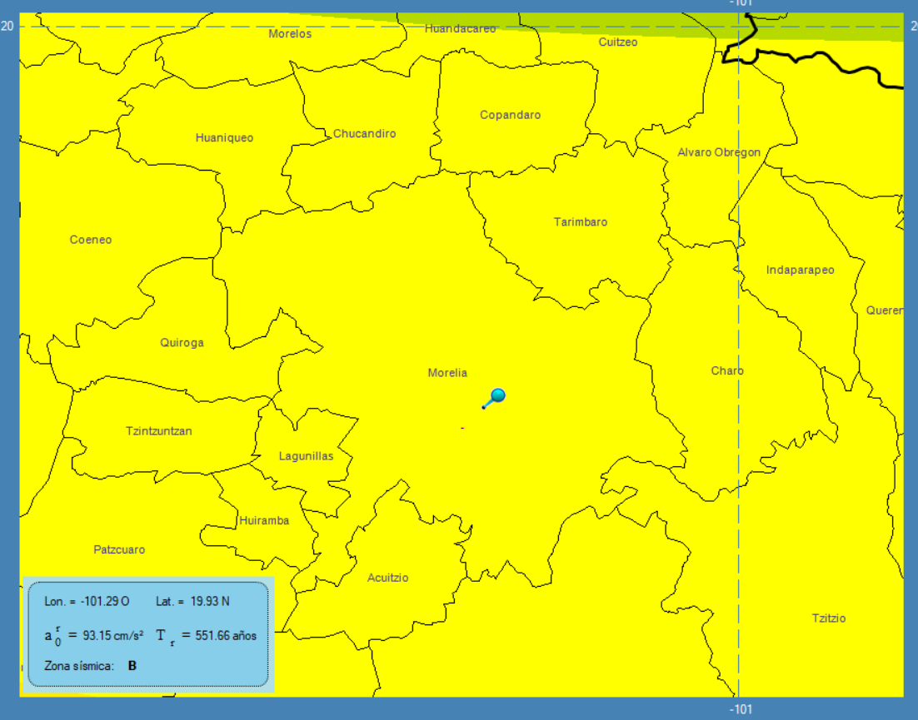

|  |
| --- |
| ***Figura 1. Ubicación de la estructura*** |

Los alcances de ésta memoria son determinar las dimensiones de los perfiles de madera y concreto que se utilizarán para construir la estructura de la casa habitación, además de revisar los muros de mampostería y su refuerzo, así como la cimentación, sus elementos de concreto reforzado, y sus respectivos armados de acero, con base al diseño sísmico.

Se utilizará el criterio de las Normas Técnicas Complementarias (NTC-2017) concreto reforzado y diseño en acero del Reglamento de construcciones del Distrito Federal, cuyas características y parámetros son considerados en las corridas del programa y en la obtención de los elementos mecánicos.

Para los efectos sísmicos, se ha utilizado el programa PRODISIS v.4.1 (CFE) para el cálculo del espectro de diseño de la zona ubicada. En el modelo analítico se muestra la parte que está sometida a los mayores esfuerzos.

Para la revisión por viento se ha considerado el Manual de Diseño de Obras Civiles por viento (CFE 2017).

**REFERENCIAS**

* Reglamento de Construcciones del Distrito Federal 2017 (RCDF-2017).
* Normas Técnicas complementarias (NTC 2017)[estructuras de acero].

**DESCRIPCIÓN DEL INMUEBLE CON REPORTE FOTOGRÁFICO**

El proyecto de la fase 2 de la casa habitación está conformado por dos niveles Habitación principal, habitación 1, habitación 2, cocina, comedor-bar, estancia, sala TV, spa y cochera, la figura 2 muestra una vista general de la estructura.

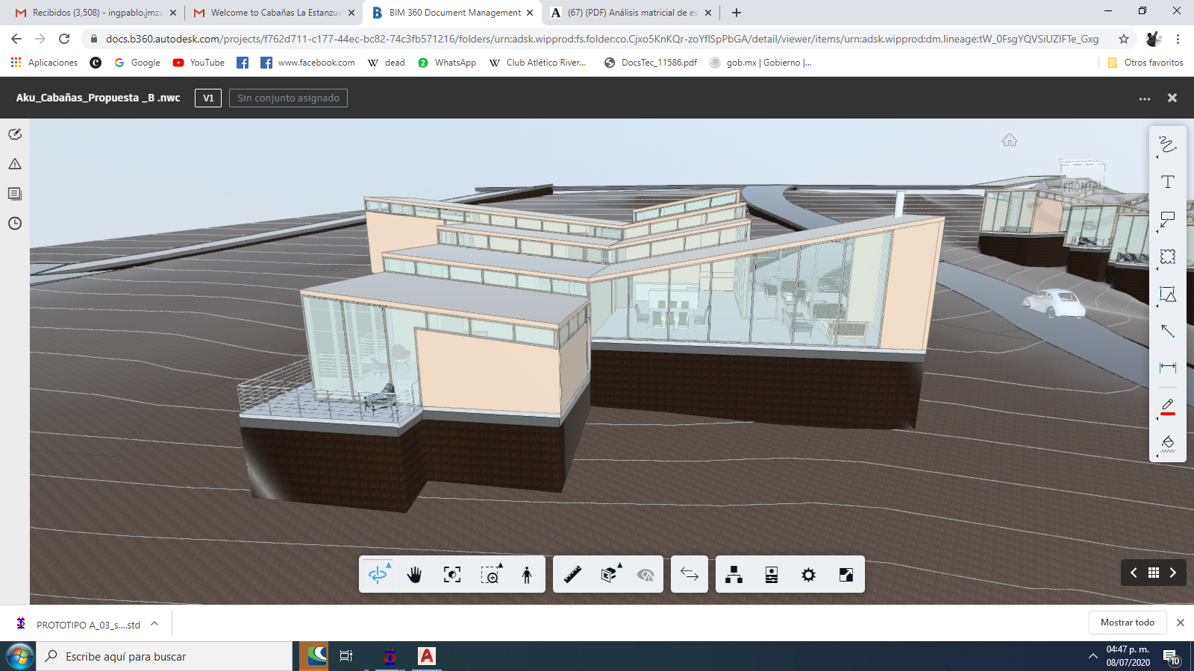

***Figura 2. Vista en 3D de la casa habitación***

La planta de la edificación se considera de tipo irregular, Figura 3. según los criterios que se consideran para la elaboración del diseño sísmico de estructuras, dada la geometría de las plantas en las que están divididos los espacios.

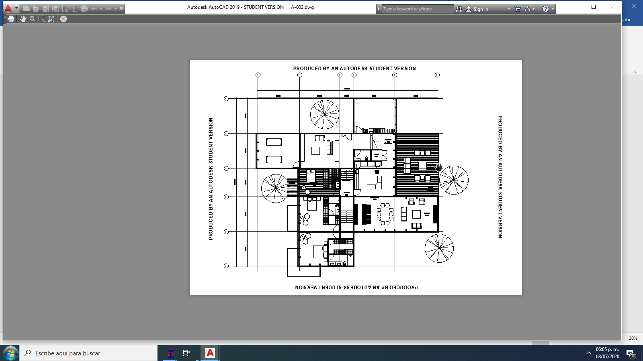

***Figura 3. Vista en planta de la estructura***

La estructura en conjunto cuenta con tres niveles: Nivel +0.00, Nivel -1.25m y Nivel -2.50 m. En los cuales se distribuyen los espacios de la siguiente manera:

* Nivel +0.00 m: Sala TV, spa y cochera:
* Nivel -1.25 m: Habitación 2, cocina, comedor-bar y estancia
* Nivel -2.50 m: Habitación principal y habitación 1.

La figura 4 muestra las vistas en tres planta y sus respectivas distribuciones. De la misma forma las techumbres de la cada uno de los espacios tiene una inclinación de 6 grados (Figura 5). Como se puede ver en sus vistas laterales, proporcionándole así una forma aerodinámica definida al cuerpo completo de la estructura, ésta forma aerodinámica que es importante al momento de realizar el análisis eólico (por viento), en el cual intervienen las fuerzas (presión y succión) que el viento puede generar en la estructura.

|  |  |
| --- | --- |
|  |  |
| *a) Nivel +0.00 m* | *b) Nivel -1.25 m* |
|  | |
| *b) Nivel -1.50 m* | |
| |  |  | | --- | --- | |  |  | | |
| ***Figura 4. Vistas en planta de la casa habitación.*** | |

**ANÁLISIS DE CARGAS**

Azotea

|  |  |
| --- | --- |
| Doble hoja de triplay | 20kg/m2 |
| Instalaciones | 20kg/m2 |
| Tejado carbonizado | 20kg/m2 |
| Centro de doble hoja | 10kg/m2 |

Entrepisos

|  |  |
| --- | --- |
| Doble hoja de triplay | 20kg/m2 |
| Instalaciones | 20kg/m2 |
| Centro de doble hoja | 10kg/m2 |
| Duela | 6kg/m2 |
| Mortero | 20kg/m2 |

**CÁLCULO DE PRESIONES DE VIENTO**

|  |  |  |  |  |
| --- | --- | --- | --- | --- |
| DATOS |  |  |  |  |
| VR = | 128 | km/hr |  |  |
| Z = | 8.5 |  |  |  |
| h = | 8 |  |  |  |
| Categoría del terreno = | | 1 |  |  |
| α_ = | 0.21 |  |  |  |
| δ = | 390 |  |  |  |
| b_ = | 0.77 |  |  |  |
| FT = | 1 |  |  |  |
|  |  |  |  |  |
| |  | | --- | | Cálculo de la velocidad de diseño | |  |  |  |  |
|  |  |  |  |  |
|  |  | Frz = | 0.522 |  |
|  |  |  |  |  |

Se calculan presiones y succiones generados por el viento en las estructuras, que actúan en dirección perpendicular a la superficie expuesta al viento. Por lo cual se utiliza la siguiente fórmula:



Donde:

: Velocidad del viento en Km/h

: presión o succión en kg/m2

Se ha usado el programa Flow Design por tratarse de un cuerpo geométrico poco convencional. Las presiones se muestran en las caras de la estructura, mismas que se han cargado al modelo de staad.pro.

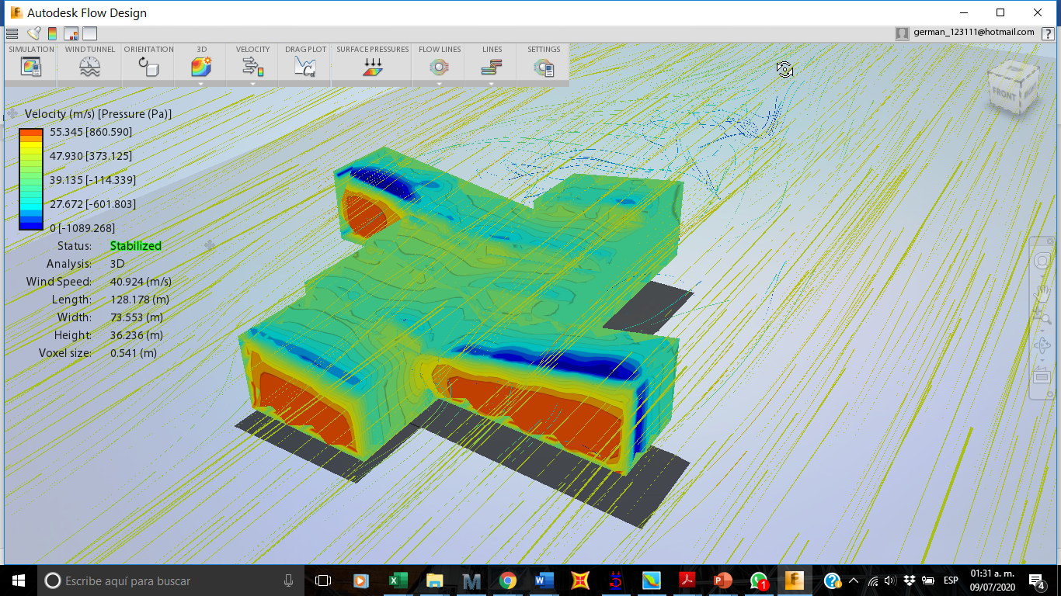

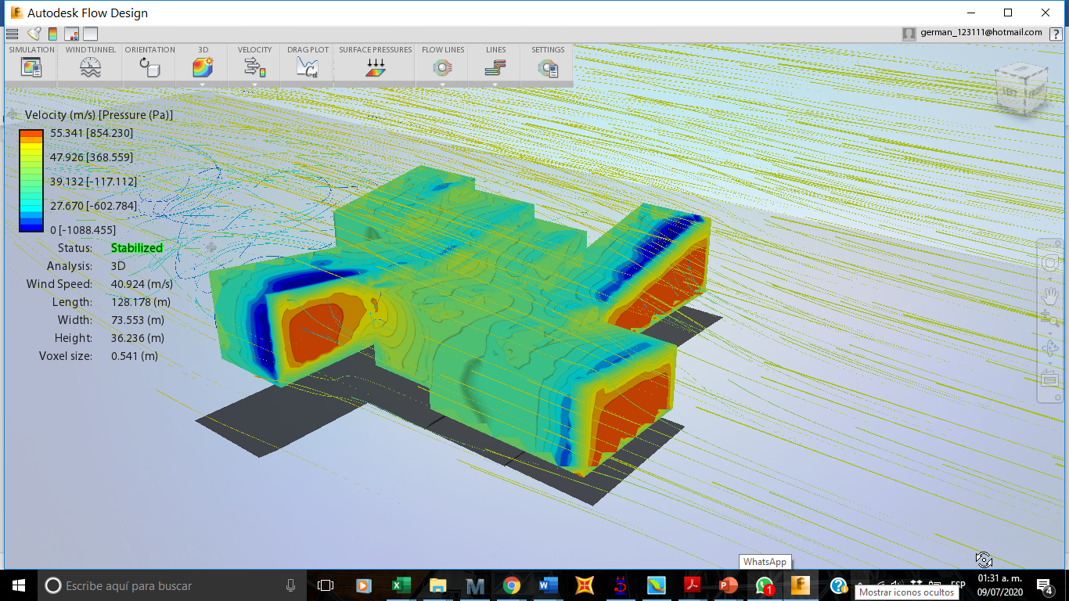

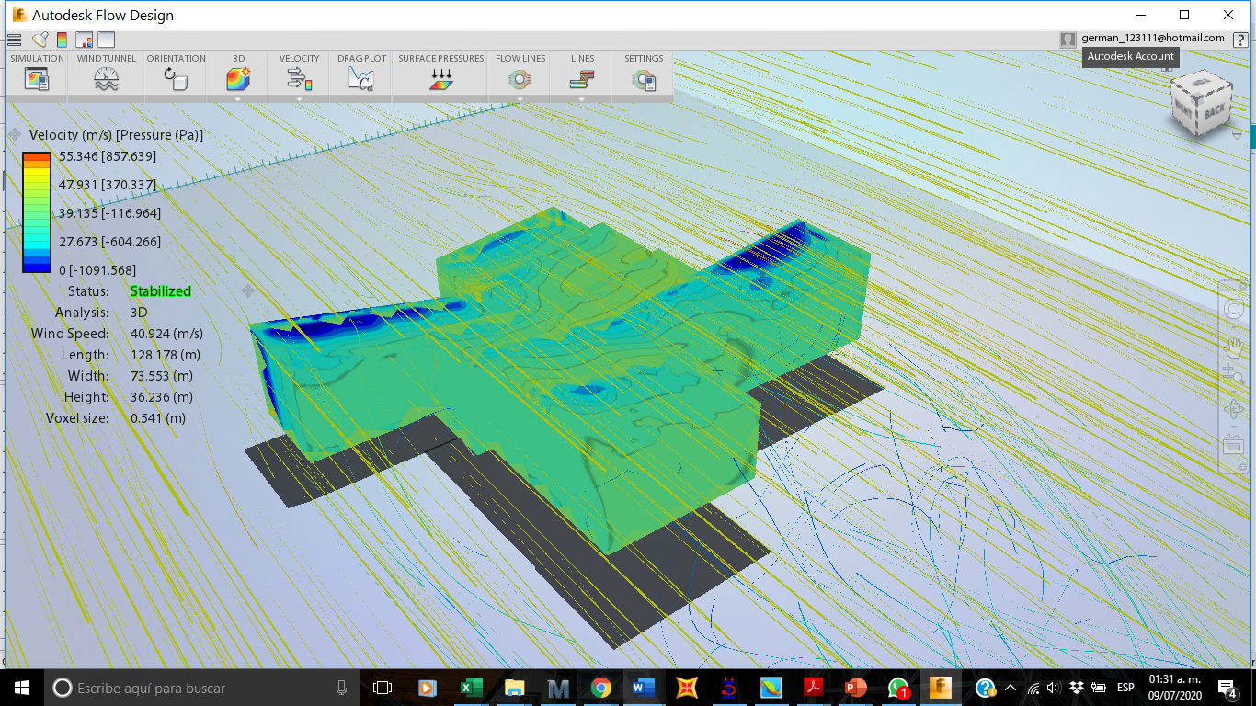

***Figura 5. Presiones de viento***



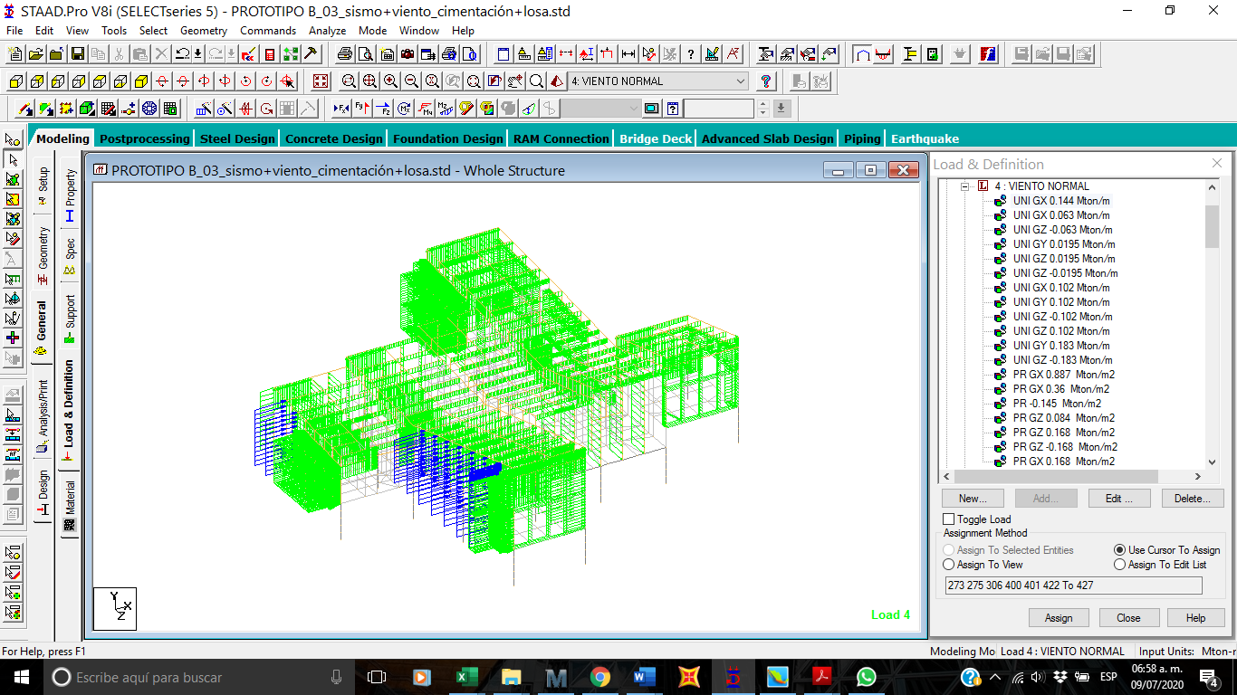

***Figura 6. Presiones de viento sobre modelo de staad.pro.***

**ESPECTRO DE DISEÑO SÍSMICO**

Para la concepción de los espectros estipulados en este Manual se formuló la siguiente

filosofía:

a) Los espectros de diseño varían en forma continua dentro del territorio

mexicano.

b) La construcción de los espectros de diseño se inicia con un parámetro

relacionado con el peligro sísmico, que es la aceleración máxima en

terreno rocoso, y se continúa con factores con que se toman en cuenta las

condiciones del terreno.

c) Las aceleraciones máximas en roca están asociadas a coeficientes de

diseño que son óptimos para el estado límite de colapso de estructuras

del Grupo B y corresponden periodos de retorno que varían espacialmente

en forma continua.

d) Los espectros de diseño son transparentes, es decir, carecen de

factores de reducción ajenos al peligro sísmico

e) Las ordenadas espectrales corresponden al 5% del amortiguamiento

crítico estructural. Podrán modificarse cuando se justifique un valor de

amortiguamiento diferente o se consideren efectos de interacción

suelo–estructura.

f) A periodo estructural largo, los espectros de desplazamiento que se derivan

de los espectros de aceleración tienden correctamente a los desplazamientos

máximos del terreno

g) A periodo estructural largo, los espectros de desplazamiento que se derivan

de los espectros de aceleración tienden correctamente a los desplazamientos

máximos del terreno.

h) Se suministran espectros de diseño para el estado límite de servicio que no

están afectados por la no linealidad del suelo.

i) Se proporcionan aceleraciones para tres niveles de importancia estructural:

convencional (B), importante (A) y muy importante (A+) (sólo para zonas de

alta sismicidad.)



***Figura 7. Espectro de diseño***

**ANÁLISIS Y DISEÑO ESTRUCTURAL**

Se utilizó como herramienta el programa computacional STAAD PRO v8i para lo cual se ha modelado toda la estructura, como un arreglo miembros con secciones transversales prismáticas ubicados dentro de 3 dimensiones limitadas por planos ortogonales entre sí, sujetos a los casos de cargas ya descrito y sus respectivas combinaciones factorizadas.

Se ha modelado toda la estructura de madera laminada la cual se va a fabricar, con los perfiles adecuados, de acuerdo al análisis y diseño estructural cual, estos elementos estarán sujetos a casos de cargas y sus respectivas combinaciones factorizadas.

Dicho modelo está constituido por archivo de datos de entrada el cual cuenta con las coordenadas de cada nodo, incidencias de los miembros, propiedades geométricas y mecánicas (módulo de elasticidad, densidad y módulo de Poisson, etc.), así como todas las combinaciones de carga a las que estará sujeto el análisis. Posteriormente, el programa se ha ejecutado y se han obtenido los resultados correspondientes, entre los que se han utilizado los elementos mecánicos de cada miembro de la estructura. El diseño de los elementos se han diseñado mediante los criterios y NTC-DF-2017.

Para formar parte de esta memoria de cálculo se seleccionó la siguiente información, siendo esta la más representativa y necesaria para su revisión de acuerdo a lo siguiente:

1. Listado con los datos de entrada del modelo de la estructura, incluyendo localización de nodos, incidencias de miembros y elementos, propiedades geométricas, propiedades mecánicas de los materiales, cargas y sus respectivas combinaciones.
2. Arreglo geométrico de modelo.
3. Cargas principales y combinaciones de carga.
4. Resultados del análisis dinámico.

El modelo matemático en staad.pro se realizó de acuerdo a los planos estructurales existentes elaborados en el año 2020 por el despacho AKURAT-ARQ.

**CORRIDA DEL PROGRAMA DE ANÁLISIS**

1. STAAD SPACE

INPUT FILE: PROTOTIPO B_03_sismo+viento_cimentación+losa.STD

2. START JOB INFORMATION

3. ENGINEER DATE 20-JUN-20

4. END JOB INFORMATION

5. INPUT WIDTH 79

6. UNIT METER MTON

7. JOINT COORDINATES

8. 1533 6.56999 2.59001 -14.27; 1534 6.56999 6.59002 -14.27

9. 1536 6.56999 2.59001 -12.77; 1537 6.56999 2.59001 -11.47

10. 1539 6.56999 6.45402 -12.77; 1540 6.56999 6.33502 -11.47

11. 1541 6.56999 2.59001 -6.27002; 1542 6.56999 5.86302 -6.27002

12. 1543 6.56999 2.59001 -10.47; 1544 6.56999 6.24502 -10.47

13. 1549 6.56999 5.95402 -7.27002; 1550 6.56999 6.04502 -8.27002

14. 1555 11.57 2.59001 -14.27; 1556 11.57 6.59002 -14.27

15. 1559 11.57 6.45402 -12.77; 1562 11.57 5.86302 -6.27002

16. 1564 11.57 6.24502 -10.47; 1566 11.57 6.04502 -8.27002

17. 1571 7.81999 2.59001 -14.27; 1572 7.81999 6.59002 -14.27

18. 1573 9.06999 2.59001 -14.27; 1574 9.06999 6.59002 -14.27

19. 1575 10.32 2.59001 -14.27; 1576 10.32 6.59002 -14.27

20. 1578 9.06999 5.86302 -6.27002; 1580 9.06999 6.24502 -10.47

21. 1581 9.06999 6.45383 -12.77; 1582 9.06999 6.04492 -8.27003

22. 1587 11.57 2.59001 -8.27002; 1613 6.56999 2.59001 -8.27002

23. 1614 11.57 2.59001 -12.77; 1615 11.57 2.59001 -10.47

24. 1617 16.57 2.59001 -8.27002; 1619 16.57 2.59001 -10.47

25. 1620 14.07 2.59001 -14.27; 1623 15.32 2.59001 -14.27

26. 1625 12.82 2.59001 -14.27; 1729 6.56999 2.59001 -7.27002

27. 1805 11.57 6.56302 -6.27002; 1806 11.57 6.74502 -8.27002

28. 1807 11.57 7.29002 -14.27; 1808 11.57 7.15402 -12.77

29. 1809 11.57 6.94502 -10.47; 1810 16.57 6.56302 -6.27002

30. 1811 16.57 6.74502 -8.27002; 1812 16.57 7.29002 -14.27

31. 1813 16.57 7.15402 -12.77; 1814 16.57 6.94502 -10.47

32. 1815 14.07 6.56302 -6.27002; 1816 14.07 6.74502 -8.27002

33. 1817 14.07 7.29002 -14.27; 1818 14.07 7.15402 -12.77

34. 1819 14.07 6.94502 -10.47; 1820 15.32 7.29002 -14.27

35. 1821 12.82 7.29002 -14.27; 1822 15.07 6.94502 -10.47

36. 1824 16.57 7.26302 -6.27002; 1825 16.57 7.44502 -8.27002

37. 1826 16.57 7.99002 -14.27; 1827 16.57 7.85402 -12.77

38. 1828 16.57 7.64502 -10.47; 1829 20.57 7.99002 -14.27

39. 1830 19.2367 7.99002 -14.27; 1831 17.9033 7.99002 -14.27

40. 1832 18.57 7.99002 -14.27; 1833 20.57 7.26302 -6.27001

41. 1834 20.57 7.44502 -8.27001; 1835 20.57 7.85402 -12.77

42. 1836 20.57 7.64502 -10.47; 1837 18.57 7.26302 -6.27002

43. 1838 18.57 7.85402 -12.77; 1839 18.57 7.64502 -10.47

44. 1840 18.57 7.44502 -8.27002; 1841 17.57 7.26302 -6.27002

45. 1842 20.57 8.79002 -0.269993; 1843 20.57 7.64502 -4.77

46. 1844 20.57 8.02602 -3.27; 1845 20.57 8.40802 -1.77; 1866 20.57 8.79902 -15.47

47. 1867 20.57 8.94402 -17.07; 1870 25.57 8.79902 -15.47

48. 1871 25.57 8.94402 -17.07; 1872 25.57 9.06002 -18.67

49. 1873 25.57 9.17002 -20.27; 1874 25.57 7.99002 -14.27

50. 1875 25.57 7.26302 -6.27002; 1876 25.57 7.44502 -8.27002

473. MEMBER INCIDENCES

474. 100 2270 2604; 101 2272 2271; 102 1837 2404; 103 2296 2405; 104 1833 2406

475. 105 2415 2414; 106 2416 2391; 107 2406 2412; 108 2405 2429; 109 2404 2427

476. 110 2427 2426; 111 2422 2427; 112 2429 2424; 113 2427 2429; 114 2495 2496

477. 115 2497 2498; 116 2495 2646; 117 2647 2646; 118 2498 2650; 119 2512 2652

478. 120 2528 2532; 121 2529 2534; 122 2532 2307; 123 2534 2308; 124 2525 2539

479. 125 2556 2440; 126 2369 2575; 127 2604 2272; 128 2606 2608; 129 2609 2610

480. 130 2608 2609; 131 2605 2611; 132 2612 2613; 133 2611 2612; 134 2607 2614

481. 135 2615 2616; 136 2614 2615; 137 2623 2624; 138 2622 2625; 139 2621 2626

482. 140 2621 2618; 141 2622 2619; 142 2623 2620; 143 2631 2632; 144 2632 2633

483. 145 2629 2627; 146 2627 2634; 147 2630 2628; 148 2628 2635; 149 2647 2170

484. 150 2649 2647; 151 2650 2512; 152 2652 2172; 153 2671 2678; 154 2672 2676

485. 155 2678 2681; 156 2676 2680; 157 2689 2415; 158 2690 2692; 159 2692 2361

486. 160 2647 2640; 161 2653 2652; 162 2652 2654; 163 2593 2592; 164 2582 2581

487. 165 2584 2583; 166 2595 2594; 167 2597 2596; 168 2586 2585; 169 2667 2665

488. 170 2694 2693; 171 2581 2587; 172 2583 2589; 173 2585 2591; 174 2592 2598

489. 175 2594 2600; 176 2596 2602; 177 2665 2664; 178 2693 2695; 179 2705 2704

490. 180 2704 2703; 181 2702 2701; 182 2701 2700; 183 2698 2697; 184 2697 2696

491. 185 2712 2710; 186 2713 2711; 187 2718 2715; 188 2719 2717; 189 2724 2721

492. 190 2725 2723; 191 2710 2708; 192 2711 2709; 193 2715 2714; 194 2717 2716

493. 195 2721 2720; 196 2723 2722; 197 2534 2531; 198 2532 2530; 200 1533 1534

494. 201 1541 2173; 202 1550 2176; 203 1549 2175; 204 1555 2285; 205 1556 1807

495. 206 1559 1808; 207 1564 1809; 208 1566 1806; 209 1562 1805; 210 1566 2329

496. 211 1564 2328; 212 1812 2323; 213 1813 2324; 214 1826 1812; 215 1827 1813

497. 216 1828 1814; 217 1825 1811; 218 1824 1810; 219 1867 1989; 220 1866 1986

498. 221 1873 1988; 222 1870 1992; 223 1946 1829; 224 1947 1833; 225 1948 1834

499. 226 1949 1835; 227 1950 1836; 228 1951 1874; 229 1954 1877; 230 1955 1878

500. 231 1979 1843; 232 1980 1844; 233 1981 1845; 234 1835 2252; 235 1836 2253

501. 236 1834 2254; 237 1959 1991; 238 1958 1990; 239 1829 2251; 240 1991 2014

502. 241 1986 2011; 242 1988 2018; 243 1992 2015; 244 2011 1931; 245 2012 1932

503. 246 2013 1933; 247 2014 1934; 248 2015 1935; 249 2018 1937; 250 2016 2019

504. 251 2017 2020; 252 1978 1842; 253 1875 1952; 254 1875 2331; 255 1974 2192

505. 256 2035 1974; 257 2038 1977; 258 2037 1976; 259 2036 1975; 260 2034 1952

506. 261 2045 2072; 262 2048 2075; 263 2047 2074; 264 2046 2073; 265 2044 2071

507. 266 2055 2098; 267 2072 2180; 268 2069 2078; 269 2078 2058; 270 2098 2190

508. 271 2080 2084; 272 2084 2096; 273 2122 2199; 274 2127 2193; 275 2130 2126

509. 276 2131 2127; 277 2140 2200; 278 2143 2198; 279 2146 2142; 280 2147 2143

510. 281 2163 1542; 282 2166 2169; 283 2169 2170; 284 2170 2167; 285 2171 2172

511. 286 2172 2161; 287 2160 2171; 288 2174 1544; 289 2163 2173; 290 1613 2178

512. 291 2178 2176; 292 1729 2177; 293 2177 2175; 294 2174 2179; 295 2179 1543

513. 296 2180 2049; 297 2182 2183; 298 2185 2184; 299 2186 2182; 300 2185 2187

514. 301 2188 2074; 302 2190 2064; 303 2192 2335; 304 2193 2123; 305 2198 2141

515. 306 2199 2126; 307 2200 2142; 308 1878 2277; 309 1953 1876; 310 1876 2568

516. 311 1977 2334; 312 1976 2333; 313 1975 2332; 314 2251 2201; 315 2252 2207

517. 316 2264 2313; 317 2267 2266; 318 1968 2603; 319 2269 2268; 320 1874 2273

518. 321 1877 2274; 322 2273 2275; 323 2274 2276; 324 2277 2211; 325 2285 1556

519. 326 2302 2311; 327 2303 2309; 328 2307 2304; 329 2309 2305; 330 2313 2267

520. 331 2327 1614; 332 2329 1587; 333 2331 2040; 334 2332 2247; 335 2333 2245

521. 336 2334 2246; 337 2335 2039; 338 2071 2050; 339 2254 2209; 340 2249 2617

522. 341 2435 2440; 342 2440 2439; 343 2437 2442; 344 2443 2446; 345 2435 2286

523. 346 2436 1840; 347 2437 2287; 348 1810 2458; 349 1815 2460; 350 2460 2459

524. 351 1562 2461; 352 2461 2456; 353 2517 2515; 354 1578 2516; 355 2516 2517

525. 356 1822 2538; 357 2538 2536; 358 2539 2537; 359 1819 2542; 360 2542 2541

526. 361 2544 2548; 362 1839 2549; 363 2543 2550; 364 2436 2443; 365 2560 2562

527. 366 2562 2561; 367 1971 2564; 368 2564 2563; 369 2568 2212; 370 1559 2327

528. 371 1816 2308; 372 2442 2450; 373 1872 1987; 374 2308 2306; 375 1871 1993

529. 376 1990 2013; 377 1989 2012; 378 1987 2017; 379 1993 2016; 380 2603 2269

530. 381 2617 2248; 382 2636 2479; 383 2636 2637; 384 2637 2638; 385 2648 2646

717. ELEMENT INCIDENCES SHELL

718. 3000 2176 2175 2177 2178; 3001 2178 2177 1729 1613; 3002 2175 2163 2173 2177

719. 3003 2177 2173 1541 1729; 3004 2173 2170 2167 1541; 3005 2127 2155 2195 2193

720. 3006 2155 2157 2196 2195; 3007 2157 2159 2197 2196; 3008 2159 2143 2198 2197

721. 3009 2193 2195 2154 2123; 3010 2195 2196 2156 2154; 3011 2196 2197 2158 2156

722. 3012 2197 2198 2141 2158; 3013 2143 2142 2200 2198; 3014 2198 2200 2140 2141

723. 3015 1974 2097 2191 2192; 3016 2097 2098 2190 2191; 3017 2098 2099 2189 2190

724. 3018 2099 2072 2180 2189; 3019 2191 2190 2064 2065; 3020 2190 2189 2063 2064

725. 3021 2189 2180 2049 2063; 3022 2185 2184 2050; 3023 2072 2180 2182 2186

726. 3024 2180 2049 2183 2182; 3025 2071 2050 2076 2079; 3026 2079 2076 2069 2078

727. 3027 2078 2069 2070 2077; 3028 1806 1566 2311 2302; 3029 1816 2308 2309 2303

728. 3030 2307 2304 2306 2308; 3031 2308 2306 2305 2309; 3032 2187 2185 2050 2071

729. 3033 2335 2065 2039; 3034 2192 2191 2065 2335; 3035 2074 2075 2182 2188

730. 3036 2075 2186 2182; 3037 1975 1976 2333 2332; 3038 2332 2333 2245 2247

731. 3039 2334 2335 2039 2246; 3040 1952 2077 1875; 3041 1816 2311 2307 2308

732. 3042 1816 2302 2311; 3043 1977 1974 2192 2334; 3044 2334 2192 2335

733. 3045 2187 2073 2185; 3046 2073 2074 2188 2185; 3047 1875 2077 2070 2331

734. 3048 2331 2070 2040; 3049 2385 2386 2343 2380; 3050 1824 1810 2403 1841

735. 3051 1841 2403 2404 1837; 3052 1837 2404 2405 2296; 3053 2296 2405 2406 1833

736. 3054 2403 2422 2427 2404; 3055 2422 2419 2426 2427; 3056 2404 2427 2429 2405

737. 3057 2427 2426 2424 2429; 3058 2286 2435 2436 1840; 3059 2287 2437 2254 1834

738. 3060 2470 2475 2476 1580; 3061 1580 2476 2477 2473; 3062 2476 2471 2474 2477

739. 3063 2477 2474 1543 2179; 3064 2489 2495 2496 2480; 3065 2495 2492 2493 2496

740. 3066 2483 2497 2498 2481; 3067 2497 2491 2494 2498; 3068 2169 2170 2517 2516

741. 3069 2170 2167 2515 2517; 3070 2516 2517 2172 2171; 3071 2517 2515 2161 2172

742. 3072 2529 2534 2308 1816; 3073 2534 2531 2306 2308; 3074 1814 2316 2538 1822

743. 3075 1822 2538 2542 1819; 3076 2538 2536 2541 2542; 3077 1819 2542 2539 2525

744. 3078 2542 2541 2537 2539; 3079 2544 2548 2549 1839; 3080 1839 2549 2550 2543

745. 3081 2543 2550 2253 1836; 3082 2556 2554 2439 2440; 3083 2344 2389 2388 2358

746. 3084 2389 2371 2385 2388; 3085 2388 2385 2380 2387; 3086 2406 2405 2429 2412

747. 3087 2412 2429 2424 2411; 3088 2286 2552 2571 2435; 3089 2435 2571 2556 2440

748. 3090 1564 2519 2573 2328; 3091 2519 1566 2329 2573; 3092 2328 2573 2574 1615

749. 3093 2573 2329 1587 2574; 3094 2333 2575 2576 2245; 3095 1976 2369 2575 2333

750. 3096 2369 1977 2334 2575; 3097 2575 2334 2246 2576; 3098 1947 2344 2389 1833

751. 3099 2406 2389 2371 2412; 3100 1833 2389 2406; 3101 2354 2370 2394

752. 3102 2354 2394 2347 2351; 3103 2380 2414 2578 2343; 3104 2303 1811 2310 2309

753. 3105 2435 2436 2443 2440; 3106 2174 2473 2477 2179; 3107 1544 2473 2174

754. 3108 2581 2013 1933 2582; 3109 2013 2583 2584 1933; 3110 2583 2012 1932 2584

755. 3111 2012 2585 2586 1932; 3112 2585 2011 1931 2586; 3113 1991 2587 2581 2014

756. 3114 2587 1990 2013 2581; 3115 1990 2589 2583 2013; 3116 2589 1989 2012 2583

757. 3117 1989 2591 2585 2012; 3118 2591 1986 2011 2585; 3119 2018 2592 2593 1937

758. 3120 2592 2017 2020 2593; 3121 2017 2594 2595 2020; 3122 2594 2016 2019 2595

759. 3123 2016 2596 2597 2019; 3124 2596 2015 1935 2597; 3125 1988 2598 2592 2018

760. 3126 2598 1987 2017 2592; 3127 1987 2600 2594 2017; 3128 2600 1993 2016 2594

761. 3129 1993 2602 2596 2016; 3130 2602 1992 2015 2596; 3131 2014 2581 2582 1934

762. 3132 2267 2609 2610 2266; 3133 2609 2269 2268 2610; 3134 2269 2612 2613 2268

763. 3135 2612 2272 2271 2613; 3136 2272 2615 2616 2271; 3137 2615 2273 2275 2616

764. 3138 2313 2608 2609 2267; 3139 2608 2603 2269 2609; 3140 2603 2611 2612 2269

765. 3141 2611 2604 2272 2612; 3142 2604 2614 2615 2272; 3143 2614 1874 2273 2615

766. 3144 2264 2606 2608 2313; 3145 2606 1968 2603 2608; 3146 1968 2605 2611 2603

767. 3147 2605 2270 2604 2611; 3148 2270 2607 2614 2604; 3149 2607 1951 1874 2614

768. 3150 1946 2264 2313 1829; 3151 2273 2621 2626 2275; 3152 2621 2274 2276 2626

769. 3153 2274 2622 2625 2276; 3154 2622 2623 2624 2625; 3155 2623 2277 2211 2624

770. 3156 1874 2618 2621 2273; 3157 2618 1877 2274 2621; 3158 1877 2619 2622 2274

771. 3159 2620 1878 2277 2623; 3160 2277 2617 2248 2211; 3161 1878 2249 2617 2277

772. 3162 2562 2632 2633 2561; 3163 2631 1971 2564 2632; 3164 2632 2564 2563 2633

773. 3165 2560 2631 2632 2562; 3166 1971 2629 2627 2564; 3167 2564 2627 2634 2563

774. 3168 2629 2630 2628 2627; 3169 2627 2628 2635 2634; 3170 2630 1876 2568 2628

775. 3171 2628 2568 2212 2635; 3172 2630 1953 1876; 3173 2174 2636 2637 2179

776. 3174 2179 2637 2638 1543; 3175 2636 2176 2178 2637; 3176 2637 2178 1613 2638

777. 3177 2495 2646 2648 2492; 3178 2640 2169 2170 2647; 3179 2640 2166 2169

778. 3180 2163 2169 2170 2173; 3181 2647 2170 2167 2649; 3182 2489 2490 2646 2495

779. 3183 2498 2650 2651 2494; 3184 2510 2513 2512 2650; 3185 2512 2652 2653 2511

780. 3186 2654 2171 2172 2652; 3187 2654 2160 2171; 3188 2650 2512 2511 2651

781. 3189 2513 2654 2652 2512; 3190 2652 2172 2161 2653; 3191 2481 2510 2650 2498

782. 3192 1814 2664 2665 2316; 3193 2664 1811 2310 2665; 3194 2437 2254 2209 2442

783. 3195 2557 2443 2446 2555; 3196 2553 1840 2436; 3197 2553 2436 2443 2557

784. 3198 1840 2287 2437 2436; 3199 2436 2437 2442 2443; 3200 2678 2669 2670 2681

785. 3201 2669 2676 2680 2670; 3202 2676 2677 2679 2680; 3203 2677 2353 2349 2679

786. 3204 2344 2671 2678 2389; 3205 2671 2356 2669 2678; 3206 2356 2672 2676 2669

787. 3207 2672 2357 2677 2676; 3208 2357 2350 2353 2677; 3209 2389 2678 2371

788. 3210 2353 2354 2351 2349; 3211 2387 2415 2414 2380; 3212 2413 2415 2387

789. 3213 2416 2683 2685 2391; 3214 2391 2685 2684 2579; 3215 2683 2417 2370 2685

790. 3216 2685 2394 2347 2684; 3217 2685 2370 2394; 3218 2414 2690 2691 2578

962. START USER TABLE

963. TABLE 1

964. UNIT METER MTON

965. WIDE FLANGE

966. OSB_MADERA

967. 0.0098 0.24 0.025 0.063 0.05 6.38867E-005 2.26602E-006 5.97917E-006 -

968. 0.006 0.0042 0.063 0.05

969. END

970. ELEMENT PROPERTY

971. 10000 TO 10015 10093 TO 10096 10295 TO 10300 10304 TO 10306 THICKNESS 0.35

972. 3000 TO 3301 THICKNESS 0.03

973. 10016 TO 10092 10097 TO 10294 10301 TO 10303 10307 10308 THICKNESS 0.12

974. DEFINE MATERIAL START

975. ISOTROPIC MADERA

976. E 881849

977. POISSON 0.2

978. DENSITY 0.45

979. ALPHA 9.9E-006

980. DAMP 0.02

981. G 308339

982. ISOTROPIC MAD_OSB

983. E 859803

984. POISSON 0.2

985. DENSITY 0.45

986. ALPHA 9.9E-006

987. DAMP 0.02

988. G 320000

989. ISOTROPIC STEEL

990. E 2.09042E+007

991. POISSON 0.3

992. DENSITY 7.83341

993. ALPHA 1.2E-005

994. DAMP 0.03

995. TYPE STEEL

996. STRENGTH FY 25819.2 FU 41584 RY 1.5 RT 1.2

997. ISOTROPIC CONCRETE

998. E 2.21467E+006

999. POISSON 0.17

1000. DENSITY 2.40262

1001. ALPHA 1E-005

1002. DAMP 0.05

1003. TYPE CONCRETE

1004. STRENGTH FCU 2500

1005. END DEFINE MATERIAL

1006. MEMBER PROPERTY AMERICAN

1007. 5200 TO 5299 PRIS YD 0.5

1008. 5300 TO 5324 PRIS YD 0.5 ZD 0.5

1009. MEMBER PROPERTY AMERICAN

1010. 100 TO 198 TABLE ST TUBE TH 0.0245 WT 0.15 DT 0.05

1011. 200 TO 391 TABLE ST TUBE TH 0.098 WT 0.2 DT 0.2

1012. 400 TO 465 TABLE ST TUBE TH 0.0745 WT 0.25 DT 0.15

1013. 1000 TO 1337 TABLE ST TUBE TH 0.095 WT 0.2 DT 0.25

1014. 600 TO 621 TABLE ST TUBE TH 0.0748 WT 0.15 DT 0.15

1015. 2000 TO 2206 TABLE ST TUBE TH 0.0495 WT 0.1 DT 0.2

1016. MEMBER PROPERTY AMERICAN

1017. 5000 TO 5165 PRIS YD 0.5 ZD 0.35

1018. CONSTANTS

1019. BETA 90 MEMB 105 106 124 126 150 153 TO 196 400 401 422 TO 429 445 TO 447 -

1020. 450 452 453 455 TO 465 1248 1303

1021. BETA 180 MEMB 2149 2159

1022. MATERIAL MADERA MEMB 100 TO 198 200 TO 391 400 TO 465 600 TO 621 1000 TO 1337 -

1023. 2000 TO 2206 3000 TO 3301

1024. MATERIAL CONCRETE MEMB 5000 TO 5165 5200 TO 5324 10000 TO 10308

1025. SUPPORTS

1026. 2777 2782 2787 2792 2797 2802 2807 2812 2817 2822 2827 2832 2837 2842 2847 -

1027. 2852 2857 2862 2867 2872 2877 2882 2887 -

1028. 2892 FIXED BUT MX MY MZ KFX 3246.57 KFY 6493.15 KFZ 3246.57

1029. 2772 TO 2774 2778 2779 2783 2784 2788 2789 2793 2794 2798 2799 2803 2804 2808 -

1030. 2809 2813 2814 2818 2819 2823 2824 2828 2829 2833 2834 2838 2839 2843 2844 -

1031. 2848 2849 2853 2854 2858 2859 2863 2864 2868 2869 2873 2874 2878 2879 2883 -

1032. 2884 2888 2889 2893 2894 FIXED BUT FY MX MY MZ KFX 3246.57 KFZ 3246.57

1033. ELEMENT RELEASE

1034. 3000 TO 3301 J1 MX MZ

1035. 3000 TO 3301 J2 MX MZ

1036. 3000 TO 3301 J3 MX MZ

1037. 3000 TO 3301 J4 MX MY

1038. MEMBER OFFSET

1039. 5085 END 0 -0.62 0

1040. CUT OFF MODE SHAPE 200

1041. LOAD 1 LOADTYPE NONE TITLE CARGA MUERTA

1042. SELFWEIGHT Y -1

1043. MEMBER LOAD

1044. 1000 TO 1097 2000 TO 2100 5000 TO 5068 UNI GY -0.044

1045. ELEMENT LOAD

1046. 10016 TO 10092 10097 TO 10294 10301 TO 10303 10307 10308 PR GY -0.026

1047. LOAD 2 LOADTYPE NONE TITLE CARGA VIVA INST

1048. MEMBER LOAD

1049. 1000 TO 1063 1065 TO 1097 2000 TO 2100 UNI GY -0.032

1050. 1000 TO 1097 2000 TO 2100 5000 TO 5068 UNI GY -0.16

1051. ELEMENT LOAD

1052. 10016 TO 10092 10097 TO 10294 10301 TO 10303 10307 10308 PR GY -0.1

1053. LOAD 3 LOADTYPE NONE TITLE CARGA VIVA MAX

1054. MEMBER LOAD

1055. 1000 TO 1063 1065 TO 1097 2000 TO 2100 UNI GY -0.064

1056. 1000 TO 1097 2000 TO 2100 5000 TO 5068 UNI GY -0.304

1057. ELEMENT LOAD

1058. 10016 TO 10092 10097 TO 10294 10301 TO 10303 10307 10308 PR GY -0.19

1059. LOAD 4 LOADTYPE WIND TITLE VIENTO NORMAL

1060. MEMBER LOAD

1061. 273 275 306 400 401 422 TO 427 UNI GX 0.144

1062. 200 209 274 276 304 351 352 UNI GX 0.063

1063. 223 239 314 411 412 UNI GZ -0.063

1064. 1006 1007 1010 TO 1026 1034 1035 1040 1041 1043 TO 1049 1054 1058 TO 1061 -

1065. 1063 1065 TO 1069 1071 TO 1076 1078 1083 1084 1086 TO 1088 1090 1092 TO 1097 -

1066. 1239 2001 2003 TO 2005 2008 2014 TO 2021 2036 2037 2042 TO 2045 2048 TO 2050 -

1067. 2052 TO 2054 2056 2059 2060 2063 2066 2067 2069 2070 2072 2075 TO 2082 2084 -

1068. 2085 2087 2088 2090 2092 TO 2100 UNI GY 0.0195

1069. 255 256 261 266 267 270 296 302 303 337 413 414 419 420 436 437 UNI GZ 0.0195

1070. 204 205 212 214 325 405 TO 407 5146 UNI GZ -0.0195

1071. 272 277 TO 280 305 307 428 429 UNI GX 0.102

1072. 1000 TO 1002 1007 TO 1009 1015 1027 TO 1033 1036 TO 1039 1042 1052 1053 1055 -

1073. 1057 1062 1070 1077 1079 TO 1082 1085 1089 1091 2000 2002 2006 2007 2009 -

1074. 2012 2013 2023 2025 2027 2030 2032 2034 2035 2038 2039 2051 2057 2061 2062 -

1075. 2064 2065 2068 2071 2073 2074 2083 2086 2089 2091 UNI GY 0.102

1076. 403 404 408 409 UNI GZ -0.102

1077. 421 441 TO 444 UNI GZ 0.102

1078. 1005 1050 1051 1056 2010 2011 2022 2024 2026 2028 2029 2031 2033 -

1079. 2058 UNI GY 0.183

1080. 402 410 UNI GZ -0.183

1081. ELEMENT LOAD

1082. 3000 TO 3003 3108 TO 3112 3114 TO 3118 3173 TO 3176 3235 3237 PR GX 0.887

1083. 3113 3131 3236 3238 PR GX 0.36

1084. 3005 3006 3009 3010 PR -0.145

1085. 3007 3008 3011 3012 PR GZ 0.084

1086. 3015 TO 3021 3033 3034 PR GZ 0.168

1087. 3025 TO 3027 3040 3047 3048 PR GZ -0.168

1088. 3022 TO 3024 3032 3035 3036 3045 3046 3119 TO 3130 3151 TO 3161 3277 -

1089. 10306 PR GX 0.168

1090. ***************************************************

1091. LOAD 12 SISMO DIN. X,

1092. *CARGA MUERTA

1093. SELFWEIGHT X 1

1094. SELFWEIGHT Y 1

1095. SELFWEIGHT Z 1

1096. MEMBER LOAD

1097. 1000 TO 1063 1065 TO 1097 2000 TO 2100 UNI GX 0.16

1098. 1000 TO 1063 1065 TO 1097 2000 TO 2100 UNI GY 0.16

1099. 1000 TO 1063 1065 TO 1097 2000 TO 2100 UNI GZ 0.16

1100. *CARGA VIVA INST.

1101. MEMBER LOAD

1102. 1000 TO 1063 1065 TO 1097 2000 TO 2100 UNI GZ 0.032

1103. 1000 TO 1097 2000 TO 2100 5000 TO 5068 UNI GZ 0.16

1104. 1000 TO 1063 1065 TO 1097 2000 TO 2100 UNI GY 0.032

1105. 1000 TO 1097 2000 TO 2100 5000 TO 5068 UNI GY 0.16

1106. 1000 TO 1063 1065 TO 1097 2000 TO 2100 UNI GZ 0.032

1107. 1000 TO 1097 2000 TO 2100 5000 TO 5068 UNI GZ 0.16

1108. SPECTRUM CQC X 1 ACC SCALE 9.81 DAMP 0.05

1109. 0 0.0372; 0.1 0.1477; 0.2 0.1477; 0.3 0.1477; 0.4 0.1477; 0.5 0.1477

1110. 0.6 0.1477; 0.7 0.1367; 0.8 0.1279; 0.9 0.1206; 1 0.1144; 1.1 0.1091

1111. 1.2 0.1044; 1.3 0.1003; 1.4 0.0967; 1.5 0.0934; 1.6 0.0904; 1.7 0.0877

1112. 1.8 0.0853; 1.9 0.083; 2 0.0809; 2.1 0.0768; 2.2 0.0726; 2.3 0.0686

1113. 2.4 0.0648; 2.5 0.0611; 2.6 0.0576; 2.7 0.0544; 2.8 0.0514; 2.9 0.0486

1114. 3 0.0459; 3.1 0.0435; 3.2 0.0412; 3.3 0.0391; 3.4 0.0371; 3.5 0.0353

1115. 3.6 0.0336; 3.7 0.032; 3.8 0.0305; 3.9 0.0291; 4 0.0278; 4.1 0.0266

1116. 4.2 0.0254; 4.3 0.0244; 4.4 0.0233; 4.5 0.0224; 4.6 0.0215; 4.7 0.0206

1117. 4.8 0.0198; 4.9 0.0191; 5 0.0184

1118. LOAD 13 SISMO DIN. Y,

1119. *CARGA MUERTA

1120. SELFWEIGHT X 1

1121. SELFWEIGHT Y 1

1122. SELFWEIGHT Z 1

1123. MEMBER LOAD

1124. 1000 TO 1063 1065 TO 1097 2000 TO 2100 UNI GX 0.16

1125. 1000 TO 1063 1065 TO 1097 2000 TO 2100 UNI GY 0.16

1126. 1000 TO 1063 1065 TO 1097 2000 TO 2100 UNI GZ 0.16

1127. *CARGA VIVA INST.

1128. MEMBER LOAD

1129. 1000 TO 1063 1065 TO 1097 2000 TO 2100 UNI GZ 0.032

1130. 1000 TO 1097 2000 TO 2100 5000 TO 5068 UNI GZ 0.16

1131. 1000 TO 1063 1065 TO 1097 2000 TO 2100 UNI GY 0.032

1132. 1000 TO 1097 2000 TO 2100 5000 TO 5068 UNI GY 0.16

1133. 1000 TO 1063 1065 TO 1097 2000 TO 2100 UNI GZ 0.032

1134. 1000 TO 1097 2000 TO 2100 5000 TO 5068 UNI GZ 0.16

1135. SPECTRUM CQC Y 1 ACC SCALE 9.81 DAMP 0.05

1136. 0 0.0372; 0.1 0.1477; 0.2 0.1477; 0.3 0.1477; 0.4 0.1477; 0.5 0.1477

1137. 0.6 0.1477; 0.7 0.1367; 0.8 0.1279; 0.9 0.1206; 1 0.1144; 1.1 0.1091

1138. 1.2 0.1044; 1.3 0.1003; 1.4 0.0967; 1.5 0.0934; 1.6 0.0904; 1.7 0.0877

1139. 1.8 0.0853; 1.9 0.083; 2 0.0809; 2.1 0.0768; 2.2 0.0726; 2.3 0.0686

1140. 2.4 0.0648; 2.5 0.0611; 2.6 0.0576; 2.7 0.0544; 2.8 0.0514; 2.9 0.0486

1141. 3 0.0459; 3.1 0.0435; 3.2 0.0412; 3.3 0.0391; 3.4 0.0371; 3.5 0.0353

1142. 3.6 0.0336; 3.7 0.032; 3.8 0.0305; 3.9 0.0291; 4 0.0278; 4.1 0.0266

1143. 4.2 0.0254; 4.3 0.0244; 4.4 0.0233; 4.5 0.0224; 4.6 0.0215; 4.7 0.0206

1144. 4.8 0.0198; 4.9 0.0191; 5 0.0184

1145. LOAD 14 SISMO DIN. Z,

1146. *CARGA MUERTA

1147. SELFWEIGHT X 1

1148. SELFWEIGHT Y 1

1149. SELFWEIGHT Z 1

1150. MEMBER LOAD

1151. 1000 TO 1063 1065 TO 1097 2000 TO 2100 UNI GX 0.16

1152. 1000 TO 1063 1065 TO 1097 2000 TO 2100 UNI GY 0.16

1153. 1000 TO 1063 1065 TO 1097 2000 TO 2100 UNI GZ 0.16

1154. *CARGA VIVA INST.

1155. MEMBER LOAD

1156. 1000 TO 1063 1065 TO 1097 2000 TO 2100 UNI GZ 0.032

1157. 1000 TO 1097 2000 TO 2100 5000 TO 5068 UNI GZ 0.16

1158. 1000 TO 1063 1065 TO 1097 2000 TO 2100 UNI GY 0.032

1159. 1000 TO 1097 2000 TO 2100 5000 TO 5068 UNI GY 0.16

1160. 1000 TO 1063 1065 TO 1097 2000 TO 2100 UNI GZ 0.032

1161. 1000 TO 1097 2000 TO 2100 5000 TO 5068 UNI GZ 0.16

1162. SPECTRUM CQC Z 1 ACC SCALE 9.81 DAMP 0.05

1163. 0 0.0372; 0.1 0.1477; 0.2 0.1477; 0.3 0.1477; 0.4 0.1477; 0.5 0.1477

1164. 0.6 0.1477; 0.7 0.1367; 0.8 0.1279; 0.9 0.1206; 1 0.1144; 1.1 0.1091

1165. 1.2 0.1044; 1.3 0.1003; 1.4 0.0967; 1.5 0.0934; 1.6 0.0904; 1.7 0.0877

1166. 1.8 0.0853; 1.9 0.083; 2 0.0809; 2.1 0.0768; 2.2 0.0726; 2.3 0.0686

1167. 2.4 0.0648; 2.5 0.0611; 2.6 0.0576; 2.7 0.0544; 2.8 0.0514; 2.9 0.0486

1168. 3 0.0459; 3.1 0.0435; 3.2 0.0412; 3.3 0.0391; 3.4 0.0371; 3.5 0.0353

1169. 3.6 0.0336; 3.7 0.032; 3.8 0.0305; 3.9 0.0291; 4 0.0278; 4.1 0.0266

1170. 4.2 0.0254; 4.3 0.0244; 4.4 0.0233; 4.5 0.0224; 4.6 0.0215; 4.7 0.0206

1171. 4.8 0.0198; 4.9 0.0191; 5 0.0184

1172. LOAD COMB 25 CM+CVMAX.

1173. 1 1.0 3 1.0

1174. LOAD COMB 29 CM+CVINST.

1175. 1 1.0 2 1.0

1176. ***********************************************************

1177. ***PARA DISEÑO ACERO AISC ASD

1178. ***********************************************************

1179. LOAD COMB 30 0.75(C.M. + C.V.I. + SX + .33SY + .33SZ)

1180. 1 0.75 2 0.75 12 0.75 13 0.2475 14 0.2475

1181. LOAD COMB 31 0.75(C.M. + C.V.I. + SX - .33SY - .33SZ)

1182. 1 0.75 2 0.75 12 0.75 13 -0.2475 14 -0.2475

1183. LOAD COMB 32 0.75(C.M. + C.V.I. + SX + .33SY - .33SZ)

1184. 1 0.75 2 0.75 12 0.75 13 0.2475 14 -0.2475

1185. LOAD COMB 33 0.75(C.M. + C.V.I. + SX - .33SY + .33SZ)

1186. 1 0.75 2 0.75 12 0.75 13 -0.2475 14 0.2475

1187. LOAD COMB 34 0.75(C.M. + C.V.I. - SX + .33SY + .33SZ)

1188. 1 0.75 2 0.75 12 -0.75 13 0.2475 14 0.2475

1189. LOAD COMB 35 0.75(C.M. + C.V.I. - SX + .33SY - .33SZ)

1190. 1 0.75 2 0.75 12 -0.75 13 0.2475 14 -0.2475

1191. LOAD COMB 36 0.75(C.M. + C.V.I. - SX - .33SY + .33SZ)

1192. 1 0.75 2 0.75 12 -0.75 13 -0.2475 14 0.2475

1193. LOAD COMB 37 0.75(C.M. + C.V.I. - SX - .33SY - .33SZ)

1194. 1 0.75 2 0.75 12 -0.75 13 -0.2475 14 -0.2475

1195. LOAD COMB 46 0.75(C.M. + C.V.I. + .33SX + .33SY + SZ)

1196. 1 0.75 2 0.75 12 0.2475 13 0.2475 14 0.75

1197. LOAD COMB 47 0.75(C.M. + C.V.I. + .33SX - .33SY - SZ)

1198. 1 0.75 2 0.75 12 0.2475 13 -0.2475 14 -0.75

1199. LOAD COMB 48 0.75(C.M. + C.V.I. + .33SX + .33SY - SZ)

1200. 1 0.75 2 0.75 12 0.2475 13 0.2475 14 -0.75

1201. LOAD COMB 49 0.75(C.M. + C.V.I. + .33SX - .33SY + SZ)

1202. 1 0.75 2 0.75 12 0.2475 13 -0.2475 14 0.75

1203. LOAD COMB 50 0.75(C.M. + C.V.I. - .33SX + .33SY + SZ)

1204. 1 0.75 2 0.75 12 -0.2475 13 0.2475 14 0.75

1205. LOAD COMB 51 0.75(C.M. + C.V.I. - .33SX + .33SY - SZ)

1206. 1 0.75 2 0.75 12 -0.2475 13 0.2475 14 -0.75

1207. LOAD COMB 52 0.75(C.M. + C.V.I. - .33SX - .33SY + SZ)

1208. 1 0.75 2 0.75 12 -0.2475 13 -0.2475 14 0.75

1209. LOAD COMB 53 0.75(C.M. + C.V.I. - .33SX - .33SY - SZ)

1210. 1 0.75 2 0.75 12 -0.2475 13 -0.2475 14 -0.75

1211. *VIENTO 75%

1212. LOAD COMB 54 0.75(C.M. + C.V. + VIENTO NORMAL)

1213. 1 0.75 2 0.75

1214. LOAD COMB 55 0.75(C.M. + C.V. + VIENTO PARALELO)

1215. 1 0.75 2 0.75

1216. ***********************************************************

1217. ***ANALISIS SISMICO DINAMICO MODAL

1218. ***PARA REVISAR DESPLAZAMIENTOS Q = 1

1219. ***********************************************************

1220. LOAD COMB 130 C.M. + C.V.I. + SX + .33SY + .33SZ

1221. 1 1.0 2 1.0 12 2.0 13 0.33 14 0.667

1222. LOAD COMB 131 C.M. + C.V.I. + SX - .33SY - .33SZ

1223. 1 1.0 2 1.0 12 2.0 13 -0.33 14 -0.667

1224. LOAD COMB 132 C.M. + C.V.I. + SX + .33SY - .33SZ

1225. 1 1.0 2 1.0 12 2.0 13 0.33 14 -0.667

1226. LOAD COMB 133 C.M. + C.V.I. + SX - .33SY + .33SZ

1227. 1 1.0 2 1.0 12 2.0 13 -0.33 14 0.667

1228. LOAD COMB 134 C.M. + C.V.I. - SX + .33SY + .33SZ

1229. 1 1.0 2 1.0 12 -2.0 13 0.33 14 0.667

1230. LOAD COMB 135 C.M. + C.V.I. - SX + .33SY - .33SZ

1231. 1 1.0 2 1.0 12 -2.0 13 0.33 14 -0.667

1232. LOAD COMB 136 C.M. + C.V.I. - SX - .33SY + .33SZ

1233. 1 1.0 2 1.0 12 -2.0 13 -0.33 14 0.667

1234. LOAD COMB 137 C.M. + C.V.I. - SX - .33SY - .33SZ

1235. 1 1.0 2 1.0 12 -2.0 13 -0.33 14 -0.667

1236. LOAD COMB 146 C.M. + C.V.I. + .33SX + .33SY + SZ

1237. 1 1.0 2 1.0 12 0.667 13 0.33 14 2.0

1238. LOAD COMB 147 C.M. + C.V.I. + .33SX - .33SY - SZ

1239. 1 1.0 2 1.0 12 0.667 13 -0.33 14 -2.0

1240. LOAD COMB 148 C.M. + C.V.I. + .33SX + .33SY - SZ

1241. 1 1.0 2 1.0 12 0.667 13 0.33 14 -2.0

1242. LOAD COMB 149 C.M. + C.V.I. + .33SX - .33SY + SZ

1243. 1 1.0 2 1.0 12 0.667 13 -0.33 14 2.0

1244. LOAD COMB 150 C.M. + C.V.I. - .33SX + .33SY + SZ

1245. 1 1.0 2 1.0 12 -0.667 13 0.33 14 2.0

1246. LOAD COMB 151 C.M. + C.V.I. - .33SX + .33SY - SZ

1247. 1 1.0 2 1.0 12 -0.667 13 0.33 14 -2.0

1248. LOAD COMB 152 C.M. + C.V.I. - .33SX - .33SY + SZ

1249. 1 1.0 2 1.0 12 -0.667 13 -0.33 14 2.0

1250. LOAD COMB 153 C.M. + C.V.I. - .33SX - .33SY - SZ

1251. 1 1.0 2 1.0 12 -0.667 13 -0.33 14 -2.0

1252. LOAD COMB 154 C.M. + C.V.I. + VIENTO NORMAL

1253. 1 1.0 2 1.0 4 1.0

1254. LOAD COMB 155 C.M. + C.V.I. + VIENTO PARALELO

1255. 1 1.0 2 1.0

1256. ***********************************************************

1257. ***ANALISIS SISMICO DINAMICO MODAL Q=2 COMBINADAS

1258. ***PARA DISEÑO A. C. I.

1259. *** 1.4CM + 1.7CV + 1.7C.ACC.

1260. ***********************************************************

1261. LOAD COMB 160 1.4 CARGA MUERTA + 1.7 CARGA VIVA MAXIMA

1262. 1 1.4 3 1.7

1263. LOAD COMB 170 0.75(1.4CM +1.7CVI + 1.7(+ SX + .33SY + .33SZ))

1264. 1 1.05 2 1.28 12 1.7 13 0.561 14 0.561

1265. LOAD COMB 171 0.75(1.4CM +1.7CVI + 1.7(+ SX - .33SY - .33SZ))

1266. 1 1.05 2 1.28 12 1.7 13 -0.561 14 -0.561

1267. LOAD COMB 172 0.75(1.4CM +1.7CVI + 1.7(+ SX + .33SY - .33SZ))

1268. 1 1.05 2 1.28 12 1.7 13 0.561 14 -0.561

1269. LOAD COMB 173 0.75(1.4CM +1.7CVI + 1.7(+ SX - .33SY + .33SZ))

1270. 1 1.05 2 1.28 12 1.7 13 -0.561 14 0.561

1271. LOAD COMB 174 0.75(1.4CM +1.7CVI + 1.7(- SX + .33SY + .33SZ))

1272. 1 1.05 2 1.28 12 -1.7 13 0.561 14 0.561

1273. LOAD COMB 175 0.75(1.4CM +1.7CVI + 1.7(- SX + .33SY - .33SZ))

1274. 1 1.05 2 1.28 12 -1.7 13 0.561 14 -0.561

1275. LOAD COMB 176 0.75(1.4CM +1.7CVI + 1.7(- SX - .33SY + .33SZ))

1276. 1 1.05 2 1.28 12 -1.7 13 -0.561 14 0.561

1277. LOAD COMB 177 0.75(1.4CM +1.7CVI + 1.7(- SX - .33SY - .33SZ))

1278. 1 1.05 2 1.28 12 -1.7 13 -0.561 14 -0.561

1279. LOAD COMB 178 0.75(1.4CM +1.7CVI + 1.7(+ .33SX + .33SY + SZ))

1280. 1 1.05 2 1.28 12 0.561 13 0.561 14 1.7

1281. LOAD COMB 179 0.75(1.4CM +1.7CVI + 1.7(+ .33SX - .33SY - SZ))

1282. 1 1.05 2 1.28 12 0.561 13 -0.561 14 -1.7

1283. LOAD COMB 180 0.75(1.4CM +1.7CVI + 1.7(+ .33SX + .33SY - SZ))

1284. 1 1.05 2 1.28 12 0.561 13 0.561 14 -1.7

1285. LOAD COMB 181 0.75(1.4CM +1.7CVI + 1.7(+ .33SX - .33SY + SZ))

1286. 1 1.05 2 1.28 12 0.561 13 -0.561 14 1.7

1287. LOAD COMB 182 0.75(1.4CM +1.7CVI + 1.7( .33SX + .33SY + SZ))

1288. 1 1.05 2 1.28 12 -0.561 13 0.561 14 1.7

1289. LOAD COMB 183 0.75(1.4CM +1.7CVI + 1.7(- .33SX + .33SY - SZ))

1290. 1 1.05 2 1.28 12 -0.561 13 0.561 14 -1.7

1291. LOAD COMB 184 0.75(1.4CM +1.7CVI + 1.7(- .33SX - .33SY + SZ))

1292. 1 1.05 2 1.28 12 -0.561 13 -0.561 14 1.7

1293. LOAD COMB 185 0.75(1.4CM +1.7CVI + 1.7(- .33SX - .33SY - SZ))

1294. 1 1.05 2 1.28 12 -0.561 13 -0.561 14 -1.7

1295. LOAD COMB 186 C.M. + C.V.I. + VIENTO NORMAL

1296. 1 1.0 2 1.0 4 1.0

1297. **********************************************************

1298. **ANALISIS SISMICO DINAMICO MODAL Q=1 COMBINADAS

1299. **PARA DISEÑO N.T.C. 2017

1300. ** 1.4(CM + CV) + 1.1C.ACC.

1301. **********************************************************

1302. LOAD COMB 260 1.4 (CARGA MUERTA + CARGA VIVA MAXIMA)

1303. 1 1.4 3 1.4

1304. LOAD COMB 270 1.4(CM +CVI) + 1.1(+ SX + .33SY + .33SZ))

1305. 1 1.4 2 1.4 12 1.1 13 0.366 14 0.366

1306. LOAD COMB 271 1.4(CM +CVI) + 1.1(+ SX - .33SY - .33SZ))

1307. 1 1.4 2 1.4 12 1.1 13 -0.366 14 -0.366

1308. LOAD COMB 272 1.4(CM +CVI) + 1.1(+ SX + .33SY - .33SZ))

1309. 1 1.4 2 1.4 12 1.1 13 0.366 14 -0.366

1310. LOAD COMB 273 1.4(CM +CVI) + 1.1(+ SX - .33SY + .33SZ))

1311. 1 1.4 2 1.4 12 1.1 13 -0.366 14 0.366

1312. LOAD COMB 274 1.4(CM +CVI) + 1.1(- SX + .33SY + .33SZ))

1313. 1 1.4 2 1.4 12 -1.1 13 0.366 14 0.366

1314. LOAD COMB 275 1.4(CM +CVI) + 1.1(- SX + .33SY - .33SZ))

1315. 1 1.4 2 1.4 12 -1.1 13 0.366 14 -0.366

1316. LOAD COMB 276 1.4(CM +CVI) + 1.1(- SX - .33SY + .33SZ))

1317. 1 1.4 2 1.4 12 -1.0 13 -0.366 14 0.366

1318. LOAD COMB 277 1.4(CM +CVI) + 1.1(- SX - .33SY - .33SZ))

1319. 1 1.4 2 1.4 12 -1.1 13 -0.366 14 -0.366

1320. LOAD COMB 278 1.4(CM +CVI) + 1.1(+ .33SX + .33SY + SZ))

1321. 1 1.4 2 1.4 12 0.366 13 0.366 14 1.1

1322. LOAD COMB 279 1.4(CM +CVI) + 1.1(+ .33SX - .33SY - SZ))

1323. 1 1.4 2 1.4 12 0.366 13 -0.366 14 -1.1

1324. LOAD COMB 280 1.4(CM +CVI) + 1.1(+ .33SX + .33SY - SZ))

1325. 1 1.4 2 1.4 12 0.366 13 0.366 14 -1.1

1326. LOAD COMB 281 1.4(CM +CVI) + 1.1(+ .33SX - .33SY + SZ))

1327. 1 1.4 2 1.4 12 0.366 13 -0.366 14 1.1

1328. LOAD COMB 282 1.4(CM +CVI) + 1.1( .33SX + .33SY + SZ))

1329. 1 1.4 2 1.4 12 -0.366 13 0.366 14 1.1

1330. LOAD COMB 283 1.4(CM +CVI) + 1.1(- .33SX + .33SY - SZ))

1331. 1 1.4 2 1.4 12 -0.366 13 0.366 14 -1.1

1332. LOAD COMB 284 1.4(CM +CVI) + 1.1(- .33SX - .33SY + SZ))

1333. 1 1.4 2 1.4 12 -0.366 13 -0.366 14 1.1

1334. LOAD COMB 285 1.4(CM +CVI) + 1.1(- .33SX - .33SY - SZ))

1335. 1 1.4 2 1.4 12 -0.366 13 -0.366 14 -1.1

1336. *VIENTO 75%

1337. LOAD COMB 286 1.4(C.M. + C.V.) + 1.1(VIENTO NORMAL)

1338. 1 1.4 2 1.4 4 1.1

1339. **********************************************************

1340. **ANALISIS SISMICO DINAMICO MODAL Q=1 COMBINADAS

1341. **PARA DISEÑO DE MADERA, CÓDIGO A.S.C.E. 7-2002

1342. **MÉTODO LRFD

1343. **********************************************************

1344. LOAD COMB 560 1.4 CM + 1.6 CVMAX

1345. 1 1.4 3 1.6

1346. LOAD COMB 570 1.2 CM + CV + 1.0(+ SX + .33SY + .33SZ))

1347. 1 1.2 3 1.0 12 1.0 13 0.333 14 0.333

1348. LOAD COMB 571 1.2 CM + CV + 1.0(+ SX - .33SY - .33SZ))

1349. 1 1.2 3 1.0 12 1.0 13 -0.333 14 -0.333

1350. LOAD COMB 572 1.2 CM + CV + 1.0(+ SX + .33SY - .33SZ))

1351. 1 1.2 3 1.0 12 1.0 13 0.333 14 -0.333

1352. LOAD COMB 573 1.2 CM + CV + 1.0(+ SX - .33SY + .33SZ))

1353. 1 1.2 3 1.0 12 1.0 13 -0.333 14 0.333

1354. LOAD COMB 574 1.2 CM + CV + 1.0(- SX + .33SY + .33SZ))

1355. 1 1.2 3 1.0 12 -1.0 13 0.333 14 0.333

1356. LOAD COMB 575 1.2 CM + CV + 1.0(- SX + .33SY - .33SZ))

1357. 1 1.2 3 1.0 12 -1.0 13 0.333 14 -0.333

1358. LOAD COMB 576 1.2 CM + CV + 1.0(- SX - .33SY + .33SZ))

1359. 1 1.2 3 1.0 12 -1.0 13 -0.333 14 0.333

1360. LOAD COMB 577 1.2 CM + CV + 1.0(- SX - .33SY - .33SZ))

1361. 1 1.2 3 1.0 12 -1.0 13 -0.333 14 -0.333

1362. LOAD COMB 578 1.2 CM + CV + 1.0(+ .33SX + .33SY + SZ))

1363. 1 1.2 3 1.0 12 0.333 13 0.333 14 1.0

1364. LOAD COMB 579 1.2 CM + CV + 1.0(+ .33SX - .33SY - SZ))

1365. 1 1.2 3 1.0 12 0.333 13 -0.333 14 -1.0

1366. LOAD COMB 580 1.2 CM + CV + 1.0(+ .33SX + .33SY - SZ))

1367. 1 1.2 3 1.0 12 0.333 13 0.333 14 -1.0

1368. LOAD COMB 581 1.2 CM + CV + 1.0(+ .33SX - .33SY + SZ))

1369. 1 1.2 3 1.0 12 0.333 13 -0.333 14 1.0

1370. LOAD COMB 582 1.2 CM + CV + 1.0( .33SX + .33SY + SZ))

1371. 1 1.2 3 1.0 12 -0.333 13 0.333 14 1.0

1372. LOAD COMB 583 1.2 CM + CV + 1.0(- .33SX + .33SY - SZ))

1373. 1 1.2 3 1.0 12 -0.333 13 0.333 14 -1.0

1374. LOAD COMB 584 1.2 CM + CV + 1.0(- .33SX - .33SY + SZ))

1375. 1 1.2 3 1.0 12 -0.333 13 -0.333 14 1.0

1376. LOAD COMB 585 1.2 CM + CV + 1.0(- .33SX - .33SY - SZ))

1377. 1 1.2 3 1.0 12 -0.333 13 -0.333 14 -1.0

1378. *VIENTO 75%

1379. LOAD COMB 586 1.2 C.M. + C.V. + 1.6(VIENTO NORMAL)

1380. 1 1.2 3 1.0 4 1.6

1381. PERFORM ANALYSIS

P R O B L E M S T A T I S T I C S

-----------------------------------

NUMBER OF JOINTS 943 NUMBER OF MEMBERS 1215

NUMBER OF PLATES 611 NUMBER OF SOLIDS 0

NUMBER OF SURFACES 0 NUMBER OF SUPPORTS 75

SOLVER USED IS THE OUT-OF-CORE BASIC SOLVER

ORIGINAL/FINAL BAND-WIDTH= 840/ 75/ 456 DOF

TOTAL PRIMARY LOAD CASES = 7, TOTAL DEGREES OF FREEDOM = 5658

TOTAL LOAD COMBINATION CASES = 92 SO FAR.

SIZE OF STIFFNESS MATRIX = 2581 DOUBLE KILO-WORDS

REQRD/AVAIL. DISK SPACE = 58.7/ 105396.9 MB

NUMBER OF MODES REQUESTED = 200

NUMBER OF EXISTING MASSES IN THE MODEL = 2829

NUMBER OF MODES THAT WILL BE USED = 200

CALCULATED FREQUENCIES FOR LOAD CASE 12

MODE FREQUENCY(CYCLES/SEC) PERIOD(SEC) ACCURACY

1 3.462 0.28886 2.403E-16

2 3.514 0.28454 4.663E-16

3 3.929 0.25449 1.865E-16

4 4.250 0.23530 0.000E+00

5 4.328 0.23105 7.687E-16

6 4.812 0.20783 0.000E+00

7 4.847 0.20632 1.226E-16

8 5.228 0.19127 1.053E-15

9 5.248 0.19053 8.363E-16

10 5.348 0.18698 1.007E-15

C O M P O S I T E D A M P I N G SUMMARY

MODE STRAIN ENERGY DAMP*ENERGY COMPOSITE DAMPING

1 7.169020E+00 1.690867E-01 0.0236

2 4.793429E+00 1.062607E-01 0.0222

3 8.381878E+00 2.152165E-01 0.0257

4 2.449649E+01 5.835575E-01 0.0238

5 6.279983E+00 1.283334E-01 0.0204

6 1.598450E+01 4.321156E-01 0.0270

7 2.315200E+01 5.682567E-01 0.0245

8 7.354812E+00 1.501948E-01 0.0204

9 9.134047E+00 1.954760E-01 0.0214

10 8.595381E+00 1.783080E-01 0.0207

MODAL WEIGHT (MODAL MASS TIMES g) IN MTON GENERALIZED

MODE X Y Z WEIGHT

1 2.971675E+00 1.345428E+00 7.158854E+01 5.870621E+00

2 1.009214E+01 8.028605E-01 4.559102E+01 3.677825E+00

3 8.468471E-01 1.989693E+00 1.452810E+02 5.731402E+00

4 1.154663E+00 2.602433E+00 2.783464E+00 1.347827E+01

5 3.320243E-01 1.246611E+00 4.253173E-01 3.022142E+00

6 8.367931E+01 2.592920E-01 1.350268E+01 7.713670E+00

7 4.693186E+00 2.346923E-01 3.288876E+01 9.629368E+00

8 1.523397E+00 5.647731E+00 4.113910E-01 2.424770E+00

9 1.327801E+00 1.146381E+01 5.194770E+00 3.111875E+00

10 2.922439E-01 5.100273E+00 3.971387E+00 2.772350E+00

CQC MODAL COMBINATION METHOD USED.

DYNAMIC WEIGHT X Y Z 2.970123E+02 3.636774E+02 4.303424E+02 MTON

MISSING WEIGHT X Y Z -1.036641E+01 -1.611717E+00 -9.819944E+00 MTON

MODAL WEIGHT X Y Z 2.866459E+02 3.620656E+02 4.205224E+02 MTON

MODE ACCELERATION-G DAMPING

---- -------------- -------

1 0.14775 0.05000

2 0.14775 0.05000

3 0.14775 0.05000

4 0.14775 0.05000

5 0.14775 0.05000

6 0.14775 0.05000

7 0.14775 0.05000

8 0.14775 0.05000

9 0.14775 0.05000

10 0.14775 0.05000

MODAL BASE ACTIONS FORCES IN MTON LENGTH IN METE

-----------------------------------------------------------

MOMENTS ARE ABOUT THE ORIGIN

MODE PERIOD FX FY FZ MX MY MZ

1 0.289 0.44 0.30 -2.16 -14.25 25.17 1.49

2 0.285 1.49 -0.42 3.17 22.42 -75.44 -17.84

3 0.254 0.13 -0.19 -1.64 -11.97 31.79 -2.86

4 0.235 0.17 0.26 -0.26 -2.07 15.72 3.19

5 0.231 0.05 0.10 0.06 -0.32 -0.03 1.03

6 0.208 12.36 0.69 4.97 39.11 -138.67 -76.02

7 0.206 0.69 0.16 -1.84 -13.76 39.04 -4.69

8 0.191 0.23 0.43 -0.12 3.92 0.64 6.96

9 0.191 0.20 0.58 0.39 4.76 -7.50 9.11

10 0.187 0.04 -0.18 0.16 -1.60 -3.24 -4.66

MASS PARTICIPATION FACTORS IN PERCENT BASE SHEAR IN MTON

-------------------------------------- ------------------

MODE X Y Z SUMM-X SUMM-Y SUMM-Z X Y Z

1 1.00 0.37 16.64 1.001 0.370 16.635 0.44 0.00 0.00

2 3.40 0.22 10.59 4.398 0.591 27.229 1.49 0.00 0.00

3 0.29 0.55 33.76 4.684 1.138 60.989 0.13 0.00 0.00

4 0.39 0.72 0.65 5.072 1.853 61.636 0.17 0.00 0.00

5 0.11 0.34 0.10 5.184 2.196 61.734 0.05 0.00 0.00

6 28.17 0.07 3.14 33.358 2.267 64.872 12.36 0.00 0.00

7 1.58 0.06 7.64 34.938 2.332 72.514 0.69 0.00 0.00

8 0.51 1.55 0.10 35.451 3.885 72.610 0.23 0.00 0.00

9 0.45 3.15 1.21 35.898 7.037 73.817 0.20 0.00 0.00

10 0.10 1.40 0.92 35.996 8.440 74.740 0.04 0.00 0.00

MODAL WEIGHT (MODAL MASS TIMES g) IN MTON GENERALIZED

MODE X Y Z WEIGHT

1 2.971675E+00 1.345428E+00 7.158854E+01 5.870621E+00

2 1.009214E+01 8.028605E-01 4.559102E+01 3.677825E+00

3 8.468471E-01 1.989693E+00 1.452810E+02 5.731402E+00

4 1.154663E+00 2.602433E+00 2.783464E+00 1.347827E+01

5 3.320243E-01 1.246611E+00 4.253173E-01 3.022142E+00

6 8.367931E+01 2.592920E-01 1.350268E+01 7.713670E+00

7 4.693186E+00 2.346923E-01 3.288876E+01 9.629368E+00

8 1.523397E+00 5.647731E+00 4.113910E-01 2.424770E+00

9 1.327801E+00 1.146381E+01 5.194770E+00 3.111875E+00

10 2.922439E-01 5.100273E+00 3.971387E+00 2.772350E+00

CQC MODAL COMBINATION METHOD USED.

DYNAMIC WEIGHT X Y Z 2.970123E+02 3.636774E+02 4.303424E+02 MTON

MISSING WEIGHT X Y Z -1.036641E+01 -1.611717E+00 -9.819944E+00 MTON

MODAL WEIGHT X Y Z 2.866459E+02 3.620656E+02 4.205224E+02 MTON

MODE ACCELERATION-G DAMPING

---- -------------- -------

1 0.14775 0.05000

2 0.14775 0.05000

3 0.14775 0.05000

4 0.14775 0.05000

5 0.14775 0.05000

6 0.14775 0.05000

7 0.14775 0.05000

8 0.14775 0.05000

9 0.14775 0.05000

10 0.14775 0.05000

MODAL BASE ACTIONS FORCES IN MTON LENGTH IN METE

-----------------------------------------------------------

MOMENTS ARE ABOUT THE ORIGIN

MODE PERIOD FX FY FZ MX MY MZ

1 0.289 0.30 0.20 -1.45 -9.59 16.94 1.01

2 0.285 -0.42 0.12 -0.89 -6.32 21.28 5.03

3 0.254 -0.19 0.29 2.51 18.35 -48.72 4.38

4 0.235 0.26 0.38 -0.40 -3.11 23.60 4.78

5 0.231 0.10 0.18 0.11 -0.61 -0.05 1.99

6 0.208 0.69 0.04 0.28 2.18 -7.72 -4.23

7 0.206 0.16 0.03 -0.41 -3.08 8.73 -1.05

8 0.191 0.43 0.83 -0.23 7.55 1.23 13.41

9 0.191 0.58 1.69 1.14 13.99 -22.03 26.76

10 0.187 -0.18 0.75 -0.66 6.66 13.53 19.47

MASS PARTICIPATION FACTORS IN PERCENT BASE SHEAR IN MTON

-------------------------------------- ------------------

MODE X Y Z SUMM-X SUMM-Y SUMM-Z X Y Z

1 1.00 0.37 16.64 1.001 0.370 16.635 0.00 0.20 0.00

2 3.40 0.22 10.59 4.398 0.591 27.229 0.00 0.12 0.00

3 0.29 0.55 33.76 4.684 1.138 60.989 0.00 0.29 0.00

4 0.39 0.72 0.65 5.072 1.853 61.636 0.00 0.38 0.00

5 0.11 0.34 0.10 5.184 2.196 61.734 0.00 0.18 0.00

6 28.17 0.07 3.14 33.358 2.267 64.872 0.00 0.04 0.00

7 1.58 0.06 7.64 34.938 2.332 72.514 0.00 0.03 0.00

8 0.51 1.55 0.10 35.451 3.885 72.610 0.00 0.83 0.00

9 0.45 3.15 1.21 35.898 7.037 73.817 0.00 1.69 0.00

10 0.10 1.40 0.92 35.996 8.440 74.740 0.00 0.75 0.00

---------------------------

TOTAL SRSS SHEAR 0.00 12.12 0.00

TOTAL 10PCT SHEAR 0.00 28.22 0.00

TOTAL ABS SHEAR 0.00 51.65 0.00

TOTAL CQC SHEAR 0.00 30.74 0.00

RESPONSE LOAD CASE 14

MODAL WEIGHT (MODAL MASS TIMES g) IN MTON GENERALIZED

MODE X Y Z WEIGHT

1 2.971675E+00 1.345428E+00 7.158854E+01 5.870621E+00

2 1.009214E+01 8.028605E-01 4.559102E+01 3.677825E+00

3 8.468471E-01 1.989693E+00 1.452810E+02 5.731402E+00

4 1.154663E+00 2.602433E+00 2.783464E+00 1.347827E+01

5 3.320243E-01 1.246611E+00 4.253173E-01 3.022142E+00

6 8.367931E+01 2.592920E-01 1.350268E+01 7.713670E+00

7 4.693186E+00 2.346923E-01 3.288876E+01 9.629368E+00

8 1.523397E+00 5.647731E+00 4.113910E-01 2.424770E+00

9 1.327801E+00 1.146381E+01 5.194770E+00 3.111875E+00

10 2.922439E-01 5.100273E+00 3.971387E+00 2.772350E+00

MODAL BASE ACTIONS FORCES IN MTON LENGTH IN METE

-----------------------------------------------------------

MOMENTS ARE ABOUT THE ORIGIN

MODE PERIOD FX FY FZ MX MY MZ

1 0.289 -2.16 -1.45 10.58 69.95 -123.56 -7.33

2 0.285 3.17 -0.89 6.74 47.66 -160.35 -37.91

3 0.254 -1.64 2.51 21.47 156.82 -416.34 37.41

4 0.235 -0.26 -0.40 0.41 3.22 -24.41 -4.95

5 0.231 0.06 0.11 0.06 -0.36 -0.03 1.16

6 0.208 4.97 0.28 2.00 15.71 -55.70 -30.54

7 0.206 -1.84 -0.41 4.86 36.42 -103.35 12.42

8 0.191 -0.12 -0.23 0.06 -2.04 -0.33 -3.62

9 0.191 0.39 1.14 0.77 9.42 -14.83 18.01

10 0.187 0.16 -0.66 0.59 -5.88 -11.94 -17.18

MASS PARTICIPATION FACTORS IN PERCENT BASE SHEAR IN MTON

-------------------------------------- ------------------

MODE X Y Z SUMM-X SUMM-Y SUMM-Z X Y Z

1 1.00 0.37 16.64 1.001 0.370 16.635 0.00 0.00 10.58

2 3.40 0.22 10.59 4.398 0.591 27.229 0.00 0.00 6.74

3 0.29 0.55 33.76 4.684 1.138 60.989 0.00 0.00 21.47

4 0.39 0.72 0.65 5.072 1.853 61.636 0.00 0.00 0.41

5 0.11 0.34 0.10 5.184 2.196 61.734 0.00 0.00 0.06

6 28.17 0.07 3.14 33.358 2.267 64.872 0.00 0.00 2.00

7 1.58 0.06 7.64 34.938 2.332 72.514 0.00 0.00 4.86

8 0.51 1.55 0.10 35.451 3.885 72.610 0.00 0.00 0.06

9 0.45 3.15 1.21 35.898 7.037 73.817 0.00 0.00 0.77

10 0.10 1.40 0.92 35.996 8.440 74.740 0.00 0.00 0.59

TOTAL SRSS SHEAR 0.00 0.00 25.83

TOTAL 10PCT SHEAR 0.00 0.00 30.06

TOTAL ABS SHEAR 0.00 0.00 61.83

TOTAL CQC SHEAR 0.00 0.00 36.63

1382. LOAD LIST 25 160 170 TO 186

1383. START CONCRETE DESIGN

1384. CODE ACI

1385. CLB 0.04 MEMB 5014 5017 5040 5079 5089 5090 5104 5122 5125 5149 5202 5203 -

1386. 5207 5211 5215 5219 5223 5243 5247 5250 5251 5255 5259 5267 5271 5275 5278 -

1387. 5279 5283 5287 5291 5294 5295 5298 TO 5300 5304 5312 5316 5319 5323

1388. CLS 0.04 MEMB 5014 5017 5040 5079 5089 5090 5104 5122 5125 5149 5202 5203 -

1389. 5207 5211 5215 5219 5223 5243 5247 5250 5251 5255 5259 5267 5271 5275 5278 -

1390. 5279 5283 5287 5291 5294 5295 5298 TO 5300 5304 5312 5316 5319 5323

1391. CLT 0.04 MEMB 5014 5017 5040 5079 5089 5090 5104 5122 5125 5149 5202 5203 -

1392. 5207 5211 5215 5219 5223 5243 5247 5250 5251 5255 5259 5267 5271 5275 5278 -

1393. 5279 5283 5287 5291 5294 5295 5298 TO 5300 5304 5312 5316 5319 5323

1394. FC 2500 MEMB 5014 5017 5040 5079 5089 5090 5104 5122 5125 5149 5202 5203 5207 -

1395. 5211 5215 5219 5223 5243 5247 5250 5251 5255 5259 5267 5271 5275 5278 5279 -

1396. 5283 5287 5291 5294 5295 5298 TO 5300 5304 5312 5316 5319 5323

1397. DESIGN COLUMN 5040 5202 5203 5207 5211 5215 5219 5223 5243 5247 5250 5251 -

1398. 5255 5259 5267 5271 5275 5278 5279 5283 5287 5291 5294 5295 5298 TO 5300 -

1399. 5304 5312 5316 5319 5323

====================================================================

COLUMN NO. 5040 DESIGN PER ACI 318-08 - AXIAL + BENDING

FY - 413.7 FC - 24.5 MPA, RECT SIZE - 350.0 X 500.0 MMS, TIED

ONLY MINIMUM STEEL IS REQUIRED.

AREA OF STEEL REQUIRED = 1750.0 SQ. MM

BAR CONFIGURATION REINF PCT. LOAD LOCATION PHI

----------------------------------------------------------

16 - 12 MM 1.034 25 END 0.650

(PROVIDE EQUAL NUMBER OF BARS ON EACH FACE)

TIE BAR NUMBER 12 SPACING 192.00 MM

====================================================================

COLUMN NO. 5202 DESIGN PER ACI 318-08 - AXIAL + BENDING

FY - 413.7 FC - 24.5 MPA, CIRC SIZE 500.0 MMS DIAMETER TIED

ONLY MINIMUM STEEL IS REQUIRED.

AREA OF STEEL REQUIRED = 1963.5 SQ. MM

BAR CONFIGURATION REINF PCT. LOAD LOCATION PHI

----------------------------------------------------------

10 - 16 MM 1.024 25 END 0.900

(EQUALLY SPACED)

TIE BAR NUMBER 12 SPACING 256.00 MM

====================================================================

COLUMN NO. 5203 DESIGN PER ACI 318-08 - AXIAL + BENDING

FY - 413.7 FC - 24.5 MPA, CIRC SIZE 500.0 MMS DIAMETER TIED

ONLY MINIMUM STEEL IS REQUIRED.

AREA OF STEEL REQUIRED = 1963.5 SQ. MM

BAR CONFIGURATION REINF PCT. LOAD LOCATION PHI

----------------------------------------------------------

10 - 16 MM 1.024 25 END 0.900

(EQUALLY SPACED)

TIE BAR NUMBER 12 SPACING 256.00 MM

====================================================================

COLUMN NO. 5207 DESIGN PER ACI 318-08 - AXIAL + BENDING

FY - 413.7 FC - 24.5 MPA, CIRC SIZE 500.0 MMS DIAMETER TIED

ONLY MINIMUM STEEL IS REQUIRED.

AREA OF STEEL REQUIRED = 1963.5 SQ. MM

BAR CONFIGURATION REINF PCT. LOAD LOCATION PHI

----------------------------------------------------------

10 - 16 MM 1.024 25 END 0.650

(EQUALLY SPACED)

TIE BAR NUMBER 12 SPACING 256.00 MM

====================================================================

COLUMN NO. 5211 DESIGN PER ACI 318-08 - AXIAL + BENDING

FY - 413.7 FC - 24.5 MPA, CIRC SIZE 500.0 MMS DIAMETER TIED

ONLY MINIMUM STEEL IS REQUIRED.

AREA OF STEEL REQUIRED = 1963.5 SQ. MM

BAR CONFIGURATION REINF PCT. LOAD LOCATION PHI

----------------------------------------------------------

10 - 16 MM 1.024 25 END 0.650

(EQUALLY SPACED)

TIE BAR NUMBER 12 SPACING 256.00 MM

====================================================================

COLUMN NO. 5215 DESIGN PER ACI 318-08 - AXIAL + BENDING

FY - 413.7 FC - 24.5 MPA, CIRC SIZE 500.0 MMS DIAMETER TIED

ONLY MINIMUM STEEL IS REQUIRED.

AREA OF STEEL REQUIRED = 1963.5 SQ. MM

BAR CONFIGURATION REINF PCT. LOAD LOCATION PHI

----------------------------------------------------------

10 - 16 MM 1.024 25 END 0.650

(EQUALLY SPACED)

TIE BAR NUMBER 12 SPACING 256.00 MM

====================================================================

COLUMN NO. 5219 DESIGN PER ACI 318-08 - AXIAL + BENDING

FY - 413.7 FC - 24.5 MPA, CIRC SIZE 500.0 MMS DIAMETER TIED

ONLY MINIMUM STEEL IS REQUIRED.

AREA OF STEEL REQUIRED = 1963.5 SQ. MM

BAR CONFIGURATION REINF PCT. LOAD LOCATION PHI

----------------------------------------------------------

10 - 16 MM 1.024 25 END 0.650

(EQUALLY SPACED)

TIE BAR NUMBER 12 SPACING 256.00 MM

====================================================================

COLUMN NO. 5223 DESIGN PER ACI 318-08 - AXIAL + BENDING

FY - 413.7 FC - 24.5 MPA, CIRC SIZE 500.0 MMS DIAMETER TIED

ONLY MINIMUM STEEL IS REQUIRED.

AREA OF STEEL REQUIRED = 1963.5 SQ. MM

BAR CONFIGURATION REINF PCT. LOAD LOCATION PHI

----------------------------------------------------------

10 - 16 MM 1.024 25 END 0.650

(EQUALLY SPACED)

TIE BAR NUMBER 12 SPACING 256.00 MM

====================================================================

COLUMN NO. 5243 DESIGN PER ACI 318-08 - AXIAL + BENDING

FY - 413.7 FC - 24.5 MPA, CIRC SIZE 500.0 MMS DIAMETER TIED

ONLY MINIMUM STEEL IS REQUIRED.

AREA OF STEEL REQUIRED = 1963.5 SQ. MM

BAR CONFIGURATION REINF PCT. LOAD LOCATION PHI

----------------------------------------------------------

10 - 16 MM 1.024 25 END 0.650

(EQUALLY SPACED)

TIE BAR NUMBER 12 SPACING 256.00 MM

====================================================================

COLUMN NO. 5247 DESIGN PER ACI 318-08 - AXIAL + BENDING

FY - 413.7 FC - 24.5 MPA, CIRC SIZE 500.0 MMS DIAMETER TIED

ONLY MINIMUM STEEL IS REQUIRED.

AREA OF STEEL REQUIRED = 1963.5 SQ. MM

BAR CONFIGURATION REINF PCT. LOAD LOCATION PHI

----------------------------------------------------------

10 - 16 MM 1.024 25 END 0.650

(EQUALLY SPACED)

TIE BAR NUMBER 12 SPACING 256.00 MM

====================================================================

COLUMN NO. 5250 DESIGN PER ACI 318-08 - AXIAL + BENDING

FY - 413.7 FC - 24.5 MPA, CIRC SIZE 500.0 MMS DIAMETER TIED

ONLY MINIMUM STEEL IS REQUIRED.

AREA OF STEEL REQUIRED = 1963.5 SQ. MM

BAR CONFIGURATION REINF PCT. LOAD LOCATION PHI

----------------------------------------------------------

10 - 16 MM 1.024 25 END 0.650

(EQUALLY SPACED)

TIE BAR NUMBER 12 SPACING 256.00 MM

====================================================================

COLUMN NO. 5251 DESIGN PER ACI 318-08 - AXIAL + BENDING

FY - 413.7 FC - 24.5 MPA, CIRC SIZE 500.0 MMS DIAMETER TIED

ONLY MINIMUM STEEL IS REQUIRED.

AREA OF STEEL REQUIRED = 1963.5 SQ. MM

BAR CONFIGURATION REINF PCT. LOAD LOCATION PHI

----------------------------------------------------------

10 - 16 MM 1.024 25 END 0.650

(EQUALLY SPACED)

TIE BAR NUMBER 12 SPACING 256.00 MM

====================================================================

COLUMN NO. 5255 DESIGN PER ACI 318-08 - AXIAL + BENDING

FY - 413.7 FC - 24.5 MPA, CIRC SIZE 500.0 MMS DIAMETER TIED

ONLY MINIMUM STEEL IS REQUIRED.

AREA OF STEEL REQUIRED = 1963.5 SQ. MM

BAR CONFIGURATION REINF PCT. LOAD LOCATION PHI

----------------------------------------------------------

10 - 16 MM 1.024 25 END 0.650

(EQUALLY SPACED)

TIE BAR NUMBER 12 SPACING 256.00 MM

====================================================================

COLUMN NO. 5259 DESIGN PER ACI 318-08 - AXIAL + BENDING

FY - 413.7 FC - 24.5 MPA, CIRC SIZE 500.0 MMS DIAMETER TIED

ONLY MINIMUM STEEL IS REQUIRED.

AREA OF STEEL REQUIRED = 1963.5 SQ. MM

BAR CONFIGURATION REINF PCT. LOAD LOCATION PHI

----------------------------------------------------------

10 - 16 MM 1.024 25 END 0.650

(EQUALLY SPACED)

TIE BAR NUMBER 12 SPACING 256.00 MM

====================================================================

COLUMN NO. 5267 DESIGN PER ACI 318-08 - AXIAL + BENDING

FY - 413.7 FC - 24.5 MPA, CIRC SIZE 500.0 MMS DIAMETER TIED

ONLY MINIMUM STEEL IS REQUIRED.

AREA OF STEEL REQUIRED = 1963.5 SQ. MM

BAR CONFIGURATION REINF PCT. LOAD LOCATION PHI

----------------------------------------------------------

10 - 16 MM 1.024 25 END 0.650

(EQUALLY SPACED)

TIE BAR NUMBER 12 SPACING 256.00 MM

====================================================================

COLUMN NO. 5271 DESIGN PER ACI 318-08 - AXIAL + BENDING

FY - 413.7 FC - 24.5 MPA, CIRC SIZE 500.0 MMS DIAMETER TIED

ONLY MINIMUM STEEL IS REQUIRED.

AREA OF STEEL REQUIRED = 1963.5 SQ. MM

BAR CONFIGURATION REINF PCT. LOAD LOCATION PHI

----------------------------------------------------------

10 - 16 MM 1.024 25 END 0.650

(EQUALLY SPACED)

TIE BAR NUMBER 12 SPACING 256.00 MM

====================================================================

COLUMN NO. 5275 DESIGN PER ACI 318-08 - AXIAL + BENDING

FY - 413.7 FC - 24.5 MPA, CIRC SIZE 500.0 MMS DIAMETER TIED

ONLY MINIMUM STEEL IS REQUIRED.

AREA OF STEEL REQUIRED = 1963.5 SQ. MM

BAR CONFIGURATION REINF PCT. LOAD LOCATION PHI

----------------------------------------------------------

10 - 16 MM 1.024 25 END 0.650

(EQUALLY SPACED)

TIE BAR NUMBER 12 SPACING 256.00 MM

====================================================================

COLUMN NO. 5278 DESIGN PER ACI 318-08 - AXIAL + BENDING

FY - 413.7 FC - 24.5 MPA, CIRC SIZE 500.0 MMS DIAMETER TIED

ONLY MINIMUM STEEL IS REQUIRED.

AREA OF STEEL REQUIRED = 1963.5 SQ. MM

BAR CONFIGURATION REINF PCT. LOAD LOCATION PHI

----------------------------------------------------------

10 - 16 MM 1.024 25 END 0.650

(EQUALLY SPACED)

TIE BAR NUMBER 12 SPACING 256.00 MM

====================================================================

COLUMN NO. 5279 DESIGN PER ACI 318-08 - AXIAL + BENDING

FY - 413.7 FC - 24.5 MPA, CIRC SIZE 500.0 MMS DIAMETER TIED

ONLY MINIMUM STEEL IS REQUIRED.

AREA OF STEEL REQUIRED = 1963.5 SQ. MM

BAR CONFIGURATION REINF PCT. LOAD LOCATION PHI

----------------------------------------------------------

10 - 16 MM 1.024 25 END 0.650

(EQUALLY SPACED)

TIE BAR NUMBER 12 SPACING 256.00 MM

********************END OF COLUMN DESIGN RESULTS********************

1400. DESIGN BEAM 5014 5017 5040 5079 5089 5090 5104 5122 5125 5149

=====================================================================

BEAM NO. 5014 DESIGN RESULTS - FLEXURE PER CODE ACI 318-08

LEN - 1250. MM FY - 414. FC - 25. MPA, SIZE - 350. X 500. MMS

LEVEL HEIGHT BAR INFO FROM TO ANCHOR

(MM) (MM) (MM) STA END

_____________________________________________________________________

1 59. 2 - 12MM 1057. 1250. NO YES

2 441. 6 - 12MM 0. 1250. YES YES

B E A M N O. 5014 D E S I G N R E S U L T S - SHEAR

AT START SUPPORT - Vu= 46.54 KNS Vc= 121.03 KNS Vs= 0.00 KNS

Tu= 4.62 KN-MET Tc= 5.6 KN-MET Ts= 0.0 KN-MET LOAD 25

NO STIRRUPS ARE REQUIRED FOR TORSION.

REINFORCEMENT FOR SHEAR IS PER CL.11.5.5.1.

PROVIDE 12 MM 2-LEGGED STIRRUPS AT 221. MM C/C FOR 190. MM

AT END SUPPORT - Vu= 67.48 KNS Vc= 121.14 KNS Vs= 0.00 KNS

Tu= 6.84 KN-MET Tc= 5.6 KN-MET Ts= 9.1 KN-MET LOAD 160

STIRRUPS ARE REQUIRED FOR TORSION.

REINFORCEMENT FOR SHEAR IS PER CL.11.5.5.1.

PROVIDE 12 MM 2-LEGGED STIRRUPS AT 166. MM C/C FOR 190. MM

ADDITIONAL LONGITUDINAL STEEL REQD. FOR TORSIONAL RESISTANCE = 1.64 SQ.CM.

___1555J____________________ 1250X 350X 500_____________________1625J____

| |

||=========================================================================||

| 6No12 H 441. 0.TO 1250 | |

| 2*12c/c221 3*12c/c166 | |

| 2No12 H 59.1057.TO 1250 |

| ===========||

| |

|___________________________________________________________________________|

_________ _________ _________ _________ _________ _________

| | | | | | | | | | | |

| oooooo | | oooooo | | oooooo | | oooooo | | oooooo | | oooooo |

| 6#12 | | 6#12 | | 6#12 | | 6#12 | | 6#12 | | 6#12 |

| | | | | | | | | | | |

| | | | | | | | | | | 2#12 |

| | | | | | | | | | | oo |

| | | | | | | | | | | |

|_________| |_________| |_________| |_________| |_________| |_________|

=====================================================================

BEAM NO. 5017 DESIGN RESULTS - FLEXURE PER CODE ACI 318-08

LEN - 1250. MM FY - 414. FC - 25. MPA, SIZE - 350. X 500. MMS

LEVEL HEIGHT BAR INFO FROM TO ANCHOR

(MM) (MM) (MM) STA END

_____________________________________________________________________

1 439. 6 - 16MM 0. 1250. YES YES

B E A M N O. 5017 D E S I G N R E S U L T S - SHEAR

AT START SUPPORT - Vu= 97.65 KNS Vc= 120.85 KNS Vs= 9.36 KNS

Tu= 8.95 KN-MET Tc= 5.8 KN-MET Ts= 11.9 KN-MET LOAD 160

STIRRUPS ARE REQUIRED FOR SHEAR AND TORSION.

PROVIDE 12 MM 2-LEGGED STIRRUPS AT 166. MM C/C FOR 190. MM

ADDITIONAL LONGITUDINAL STEEL REQD. FOR TORSIONAL RESISTANCE = 2.15 SQ.CM.

AT END SUPPORT - Vu= 102.01 KNS Vc= 120.85 KNS Vs= 15.17 KNS

Tu= 8.95 KN-MET Tc= 5.8 KN-MET Ts= 11.9 KN-MET LOAD 160

STIRRUPS ARE REQUIRED FOR SHEAR AND TORSION.

PROVIDE 12 MM 2-LEGGED STIRRUPS AT 166. MM C/C FOR 190. MM

ADDITIONAL LONGITUDINAL STEEL REQD. FOR TORSIONAL RESISTANCE = 2.15 SQ.CM.

___1575J____________________ 1249X 350X 500_____________________1555J____

| |

||=========================================================================||

| 6No16 H 439. 0.TO 1250 |

| 3*12c/c166 3*12c/c166 |

| |

| |

| |

|___________________________________________________________________________|

_________ _________ _________ _________ _________ _________

| | | | | | | | | | | |

| oooooo | | oooooo | | oooooo | | oooooo | | oooooo | | oooooo |

| 6#16 | | 6#16 | | 6#16 | | 6#16 | | 6#16 | | 6#16 |

| | | | | | | | | | | |

| | | | | | | | | | | |

| | | | | | | | | | | |

| | | | | | | | | | | |

|_________| |_________| |_________| |_________| |_________| |_________|

=====================================================================

BEAM NO. 5040 DESIGN RESULTS - FLEXURE PER CODE ACI 318-08

LEN - 500. MM FY - 414. FC - 25. MPA, SIZE - 350. X 500. MMS

LEVEL HEIGHT BAR INFO FROM TO ANCHOR

(MM) (MM) (MM) STA END

_____________________________________________________________________

1 441. 6 - 12MM 0. 500. YES YES

B E A M N O. 5040 D E S I G N R E S U L T S - SHEAR

** LOCATION FOR DESIGN FOR SHEAR AT START OF MEMBER 5040 IS BEYOND

THE MIDPOINT OF MEMBER. DESIGN FOR SHEAR AND TORSION NOT PERFORMED.

** LOCATION FOR DESIGN FOR SHEAR AT END OF MEMBER 5040 IS BEYOND

THE MIDPOINT OF MEMBER. DESIGN FOR SHEAR AND TORSION NOT PERFORMED.

___2339J____________________ 499X 350X 500_____________________2953J____

| |

||=========================================================================||

| 6No12 H 441. 0.TO 500 |

| |

| |

| |

| |

|___________________________________________________________________________|

_________ _________ _________ _________ _________ _________

| | | | | | | | | | | |

| oooooo | | oooooo | | oooooo | | oooooo | | oooooo | | oooooo |

| 6#12 | | 6#12 | | 6#12 | | 6#12 | | 6#12 | | 6#12 |

| | | | | | | | | | | |

| | | | | | | | | | | |

| | | | | | | | | | | |

| | | | | | | | | | | |

|_________| |_________| |_________| |_________| |_________| |_________|

=====================================================================

BEAM NO. 5079 DESIGN RESULTS - FLEXURE PER CODE ACI 318-08

LEN - 750. MM FY - 414. FC - 25. MPA, SIZE - 350. X 500. MMS

LEVEL HEIGHT BAR INFO FROM TO ANCHOR

(MM) (MM) (MM) STA END

_____________________________________________________________________

1 63. 2 - 20MM 0. 750. YES YES

B E A M N O. 5079 D E S I G N R E S U L T S - SHEAR

** LOCATION FOR DESIGN FOR SHEAR AT START OF MEMBER 5079 IS BEYOND

THE MIDPOINT OF MEMBER. DESIGN FOR SHEAR AND TORSION NOT PERFORMED.

** LOCATION FOR DESIGN FOR SHEAR AT END OF MEMBER 5079 IS BEYOND

THE MIDPOINT OF MEMBER. DESIGN FOR SHEAR AND TORSION NOT PERFORMED.

___1533J____________________ 750X 350X 500_____________________2970J____

| |

| |

| |

| |

| 2No20 H 63. 0.TO 750 |

||=========================================================================||

| |

|___________________________________________________________________________|

_________ _________ _________ _________ _________ _________

| | | | | | | | | | | |

| | | | | | | | | | | |

| | | | | | | | | | | |

| | | | | | | | | | | |

| 2#20 | | 2#20 | | 2#20 | | 2#20 | | 2#20 | | 2#20 |

| oo | | oo | | oo | | oo | | oo | | oo |

| | | | | | | | | | | |

|_________| |_________| |_________| |_________| |_________| |_________|

=====================================================================

BEAM NO. 5089 DESIGN RESULTS - FLEXURE PER CODE ACI 318-08

LEN - 1000. MM FY - 414. FC - 25. MPA, SIZE - 350. X 500. MMS

LEVEL HEIGHT BAR INFO FROM TO ANCHOR

(MM) (MM) (MM) STA END

_____________________________________________________________________

1 439. 6 - 16MM 0. 1000. YES YES

B E A M N O. 5089 D E S I G N R E S U L T S - SHEAR

AT START SUPPORT - Vu= 101.50 KNS Vc= 120.85 KNS Vs= 14.48 KNS

Tu= 6.98 KN-MET Tc= 5.6 KN-MET Ts= 9.3 KN-MET LOAD 160

STIRRUPS ARE REQUIRED FOR SHEAR AND TORSION.

PROVIDE 12 MM 2-LEGGED STIRRUPS AT 166. MM C/C FOR 65. MM

ADDITIONAL LONGITUDINAL STEEL REQD. FOR TORSIONAL RESISTANCE = 1.67 SQ.CM.

AT END SUPPORT - Vu= 102.25 KNS Vc= 120.85 KNS Vs= 15.49 KNS

Tu= 6.98 KN-MET Tc= 5.6 KN-MET Ts= 9.3 KN-MET LOAD 160

STIRRUPS ARE REQUIRED FOR SHEAR AND TORSION.

PROVIDE 12 MM 2-LEGGED STIRRUPS AT 166. MM C/C FOR 65. MM

ADDITIONAL LONGITUDINAL STEEL REQD. FOR TORSIONAL RESISTANCE = 1.67 SQ.CM.

___1537J____________________ 999X 350X 500_____________________1543J____

| |

||=========================================================================||

| 6No16 H 439. 0.TO 1000 |

| 2*12c/c166 2*12c/c166 |

| |

| |

| |

|___________________________________________________________________________|

_________ _________ _________ _________ _________ _________

| | | | | | | | | | | |

| oooooo | | oooooo | | oooooo | | oooooo | | oooooo | | oooooo |

| 6#16 | | 6#16 | | 6#16 | | 6#16 | | 6#16 | | 6#16 |

| | | | | | | | | | | |

| | | | | | | | | | | |

| | | | | | | | | | | |

| | | | | | | | | | | |

|_________| |_________| |_________| |_________| |_________| |_________|

=====================================================================

BEAM NO. 5090 DESIGN RESULTS - FLEXURE PER CODE ACI 318-08

LEN - 1100. MM FY - 414. FC - 25. MPA, SIZE - 350. X 500. MMS

LEVEL HEIGHT BAR INFO FROM TO ANCHOR

(MM) (MM) (MM) STA END

__________________________________________________________________

1 59. 2 - 12MM 939. 1100. NO YES

2 441. 5 - 12MM 0. 1100. YES YES

B E A M N O. 5090 D E S I G N R E S U L T S – SHEAR

AT START SUPPORT - Vu= 49.38 KNS Vc= 125.47 KNS Vs= 0.00 KNS

Tu= 4.10 KN-MET Tc= 5.5 KN-MET Ts= 0.0 KN-MET LOAD 25

NO STIRRUPS ARE REQUIRED FOR TORSION.

REINFORCEMENT FOR SHEAR IS PER CL.11.5.5.1.

PROVIDE 12 MM 2-LEGGED STIRRUPS AT 221. MM C/C FOR 115. MM

AT END SUPPORT - Vu= 48.42 KNS Vc= 125.47 KNS Vs= 0.00 KNS

Tu= 4.10 KN-MET Tc= 5.5 KN-MET Ts= 0.0 KN-MET LOAD 25

NO STIRRUPS ARE REQUIRED FOR TORSION.

REINFORCEMENT FOR SHEAR IS PER CL.11.5.5.1.

PROVIDE 12 MM 2-LEGGED STIRRUPS AT 221. MM C/C FOR 115. MM

___1543J____________________ 1099X 350X 500_____________________2638J____

| |

||=========================================================================||

| 5No12 H 441. 0.TO 1100 | |

| 2*12c/c221 2*12c/c221 | |

| 2No12 H 59. 939.TO 1100 |

| ===========||

| |

|___________________________________________________________________________|

_________ _________ _________ _________ _________ _________

| | | | | | | | | | | |

| ooooo | | ooooo | | ooooo | | ooooo | | ooooo | | ooooo |

| 5#12 | | 5#12 | | 5#12 | | 5#12 | | 5#12 | | 5#12 |

| | | | | | | | | | | |

| | | | | | | | | | | 2#12 |

| | | | | | | | | | | oo |

| | | | | | | | | | | |

|_________| |_________| |_________| |_________| |_________| |_________|

=====================================================================

BEAM NO. 5104 DESIGN RESULTS - FLEXURE PER CODE ACI 318-08

LEN - 1500. MM FY - 414. FC - 25. MPA, SIZE - 350. X 500. MMS

LEVEL HEIGHT BAR INFO FROM TO ANCHOR

(MM) (MM) (MM) STA END

_____________________________________________________________________

1 59. 2 - 12MM 0. 903. YES NO

2 437. 2 - 20MM 0. 1500. YES YES

B E A M N O. 5104 D E S I G N R E S U L T S - SHEAR

AT START SUPPORT - Vu= 71.39 KNS Vc= 126.89 KNS Vs= 0.00 KNS

Tu= 2.73 KN-MET Tc= 5.5 KN-MET Ts= 0.0 KN-MET LOAD 160

NO STIRRUPS ARE REQUIRED FOR TORSION.

REINFORCEMENT FOR SHEAR IS PER CL.11.5.5.1.

PROVIDE 12 MM 2-LEGGED STIRRUPS AT 221. MM C/C FOR 315. MM

AT END SUPPORT - Vu= 48.95 KNS Vc= 126.99 KNS Vs= 0.00 KNS

Tu= 2.02 KN-MET Tc= 5.5 KN-MET Ts= 0.0 KN-MET LOAD 25

NO STIRRUPS ARE REQUIRED FOR TORSION.

REINFORCEMENT FOR SHEAR IS PER CL.11.5.5.1.

PROVIDE 12 MM 2-LEGGED STIRRUPS AT 221. MM C/C FOR 315. MM

___2134J____________________ 1500X 350X 500_____________________2135J____

| |

||=========================================================================||

| 2No20 H 437.| 0.TO 1500| |

| 3*12c/c221 | | 3*12c/c221 |

| 2No12 H 59.| 0.TO 903| |

||============================================ |

| |

|___________________________________________________________________________|

_________ _________ _________ _________ _________ _________

| | | | | | | | | | | |

| oo | | oo | | oo | | oo | | oo | | oo |

| 2#20 | | 2#20 | | 2#20 | | 2#20 | | 2#20 | | 2#20 |

| | | | | | | | | | | |

| 2#12 | | 2#12 | | 2#12 | | 2#12 | | | | |

| oo | | oo | | oo | | oo | | | | |

| | | | | | | | | | | |

|_________| |_________| |_________| |_________| |_________| |_________

1402. FINISH

*********** END OF THE STAAD.Pro RUN ***********

**** DATE= JUL 9,2020 TIME= 4:45:18 ****

**REPORTE FOTOGRÁFICO DE DISEÑO**

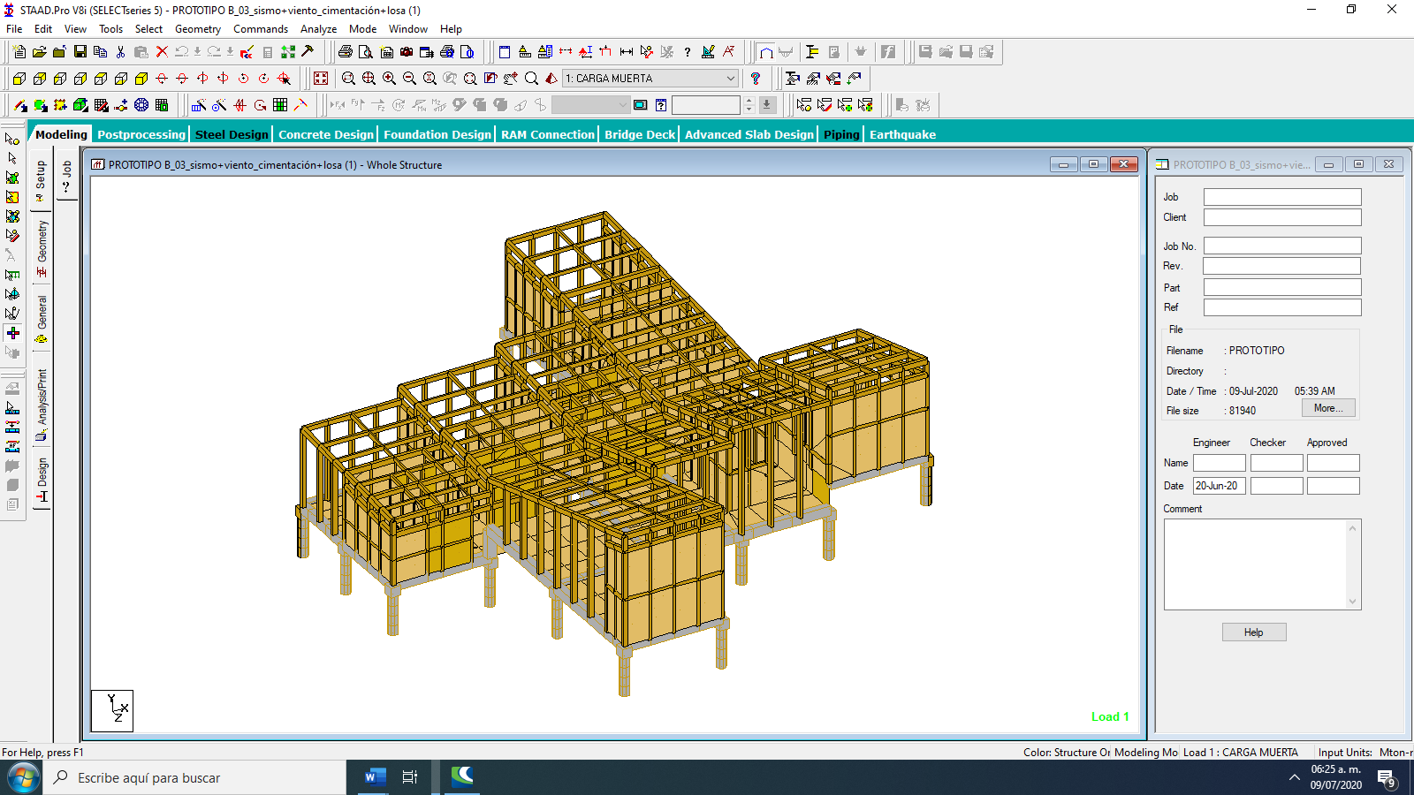

1. *Vista general del prototipo B*

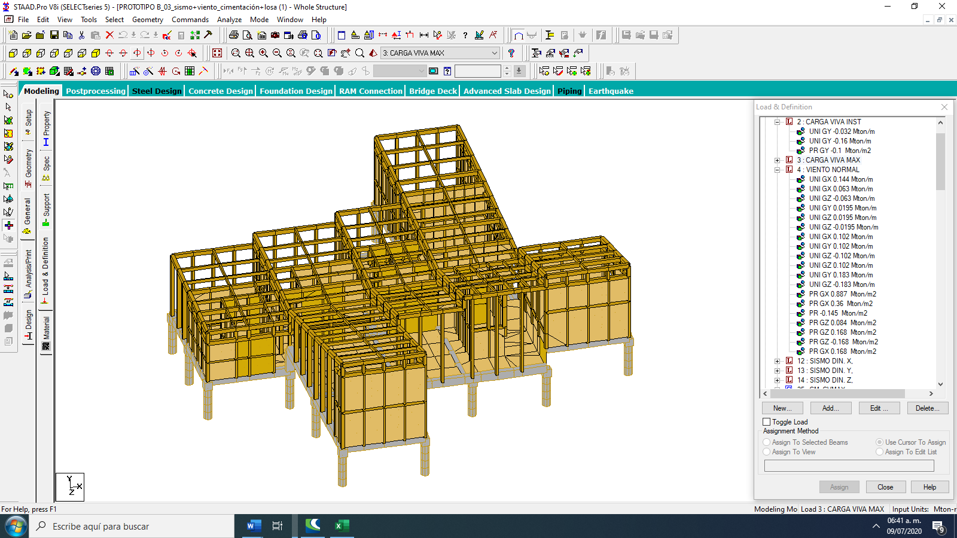

1. *Vista lateral de prototipo B*

***Figura 8. Modelo matemático del para simulación del comportamiento estructural de la casa-habitación (estructura conformada por elementos de madera laminada y cimentación de concreto reforzado)***

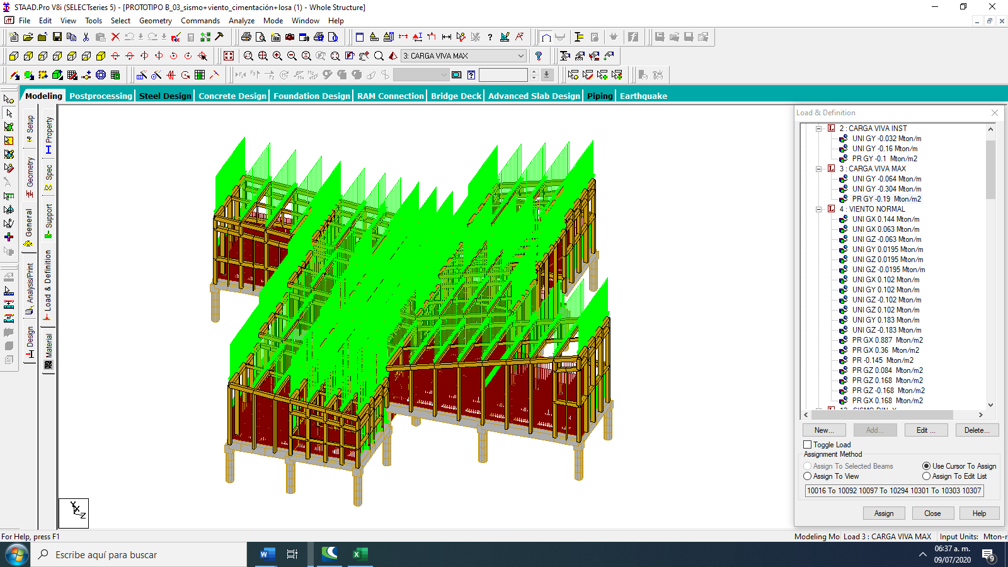

***Figura 9. Cargas aplicadas a la estructura***

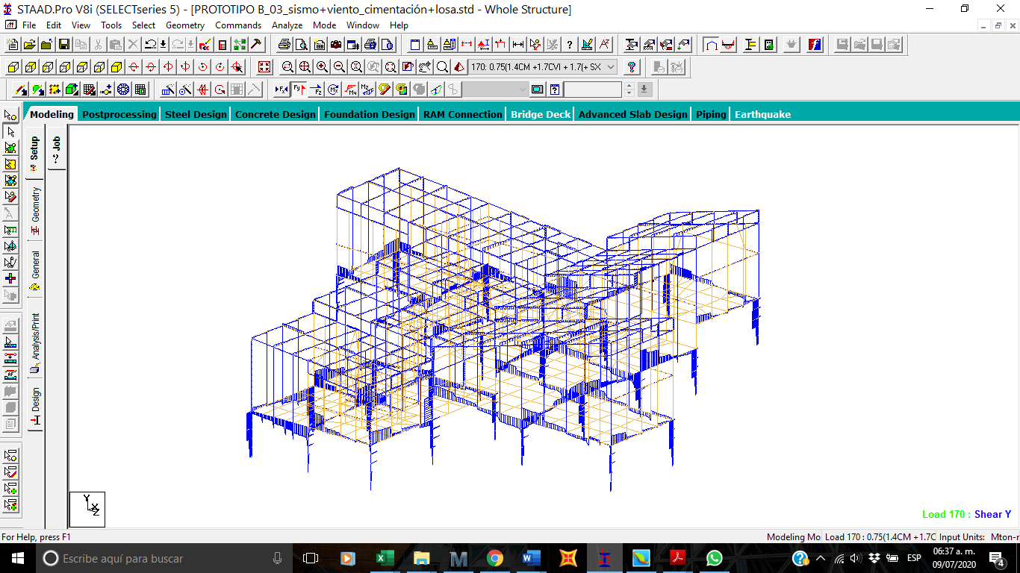

***Figura 10. Diagrama de fuerza cortante***

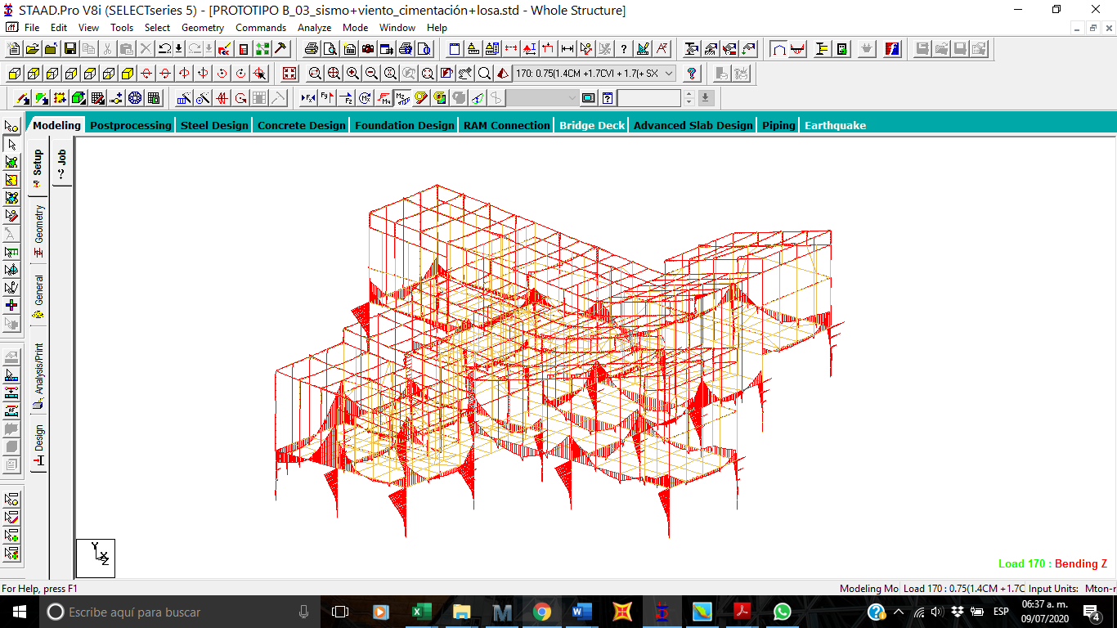

***Figura 11. Diagrama de momentos flexionantes de los elementos***

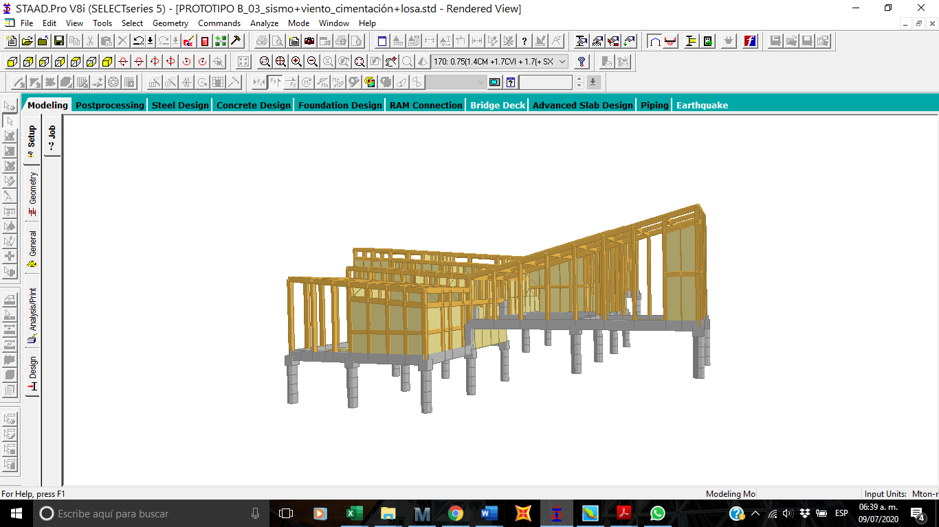

***Figura 12. Vista general de la estructura y su cimentación***

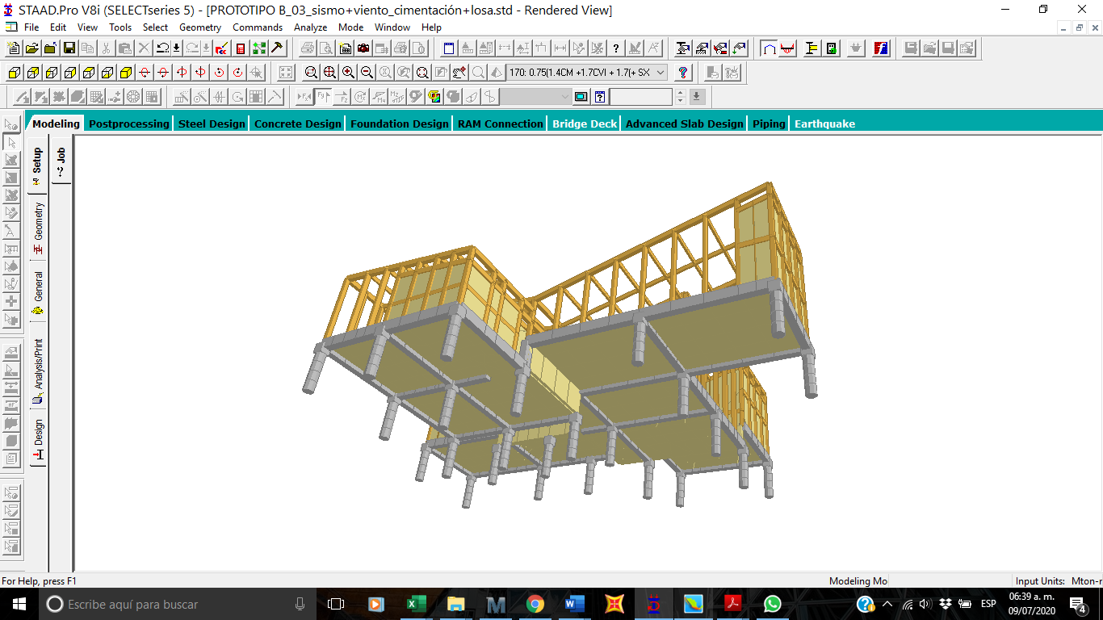

***Figura 13. Vista inferior***

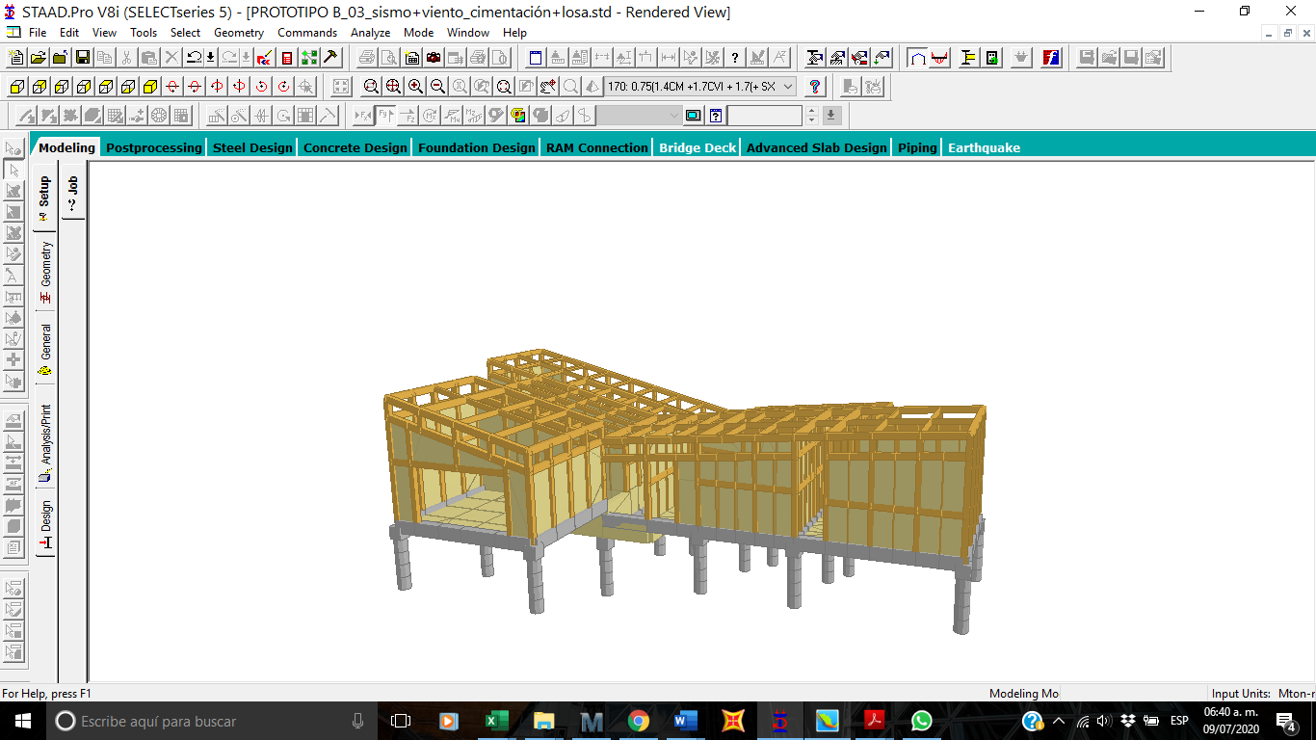

***Figura 14. Vista trasera***

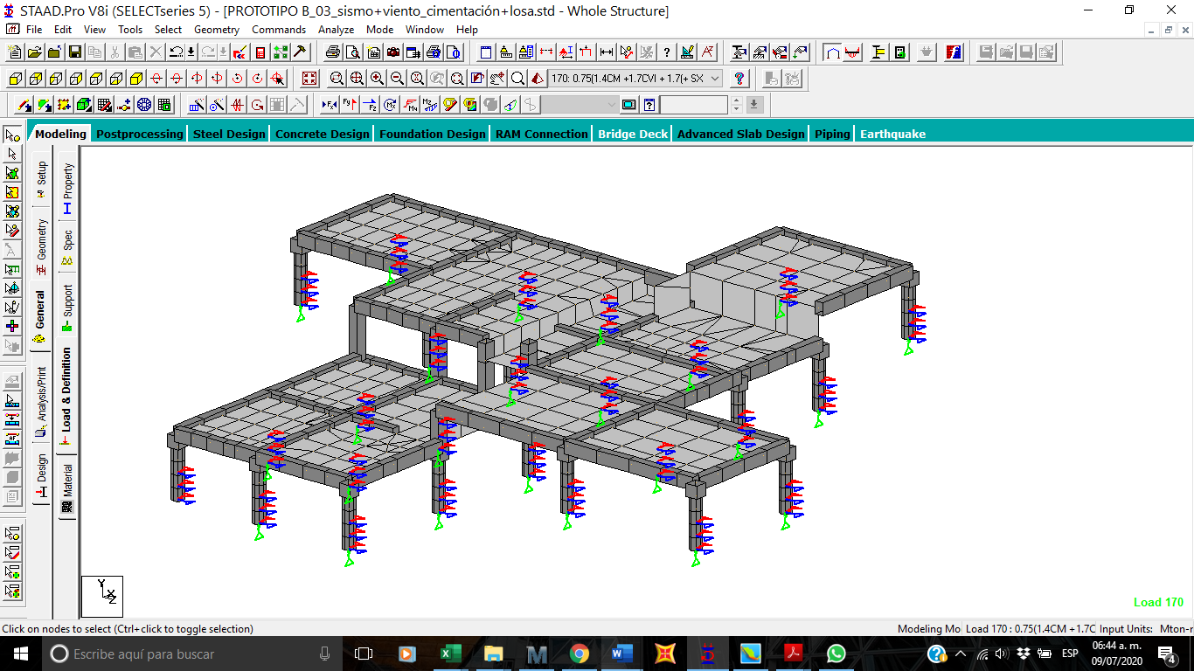

***Figura 15. Módulos de reacción del suelo en la cimentación***

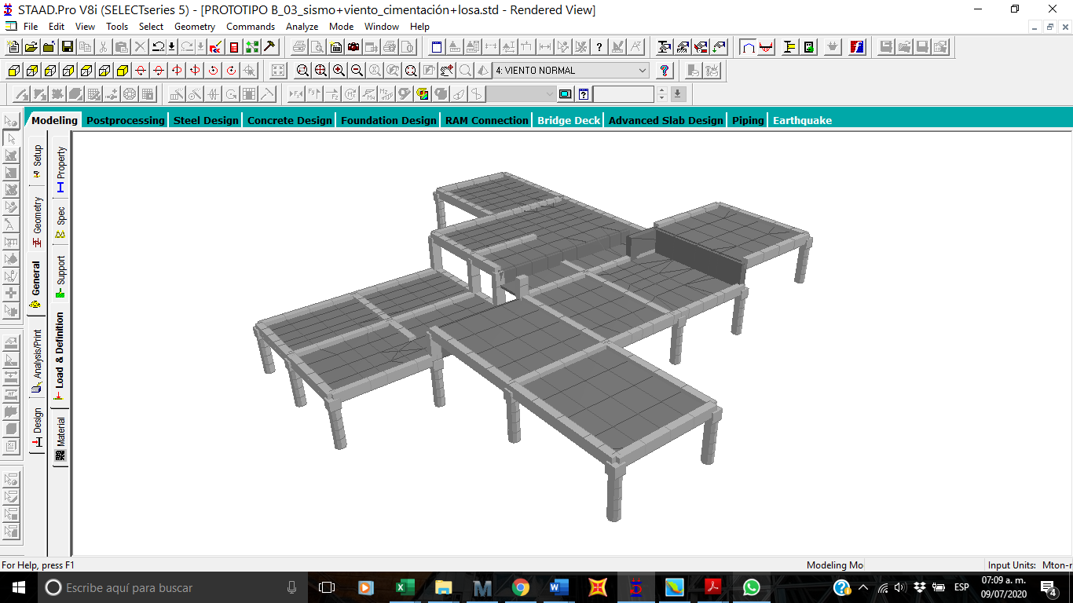

***Figura 16. Isométrico de cimentación: Micropilotes, trabes, columnas, losas y muro de concreto reforzado.***

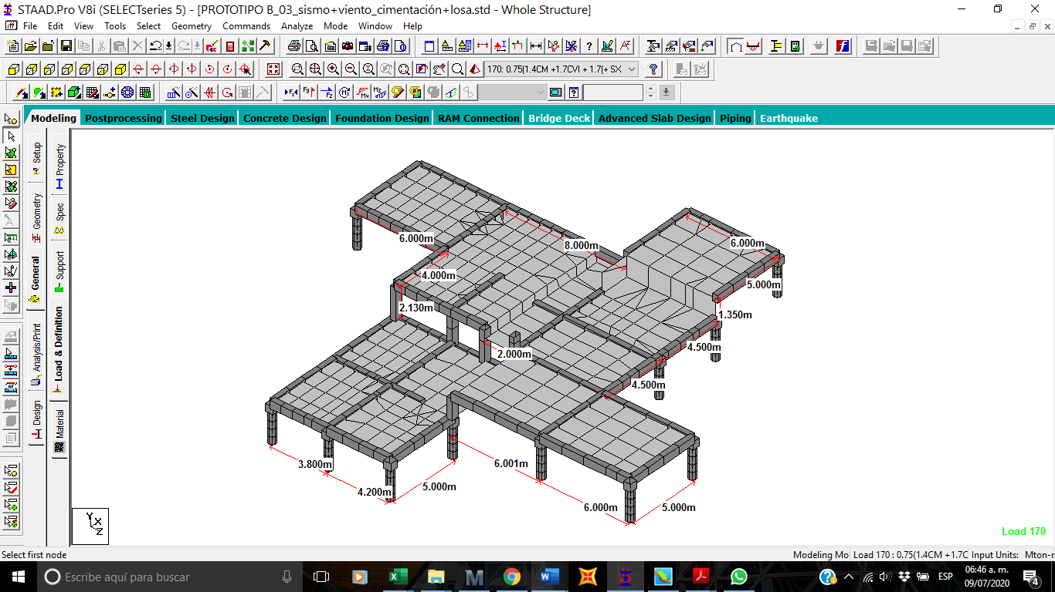

***Figura 17. Isométrico (acotado) de cimentación: Micropilotes, trabes, columnas, losas y muro de concreto reforzado.***

**Análisis de micropilote.**

Para el análisis del micropilote, se realiza el modelo del suelo a partir de resortes equivalentes al módulo de reacción, tal como se muestra a continuación.

Se tomó el criterio de Terzaghi, K (1955) para determinar el módulo de reacción k, tal como se muestra en la siguiente tabla, en donde se ha usado el valor más bajo por ser un suelo de roca blanda, la siguiente tabla se muestra el valor del módulo de reacción de acuerdo a Terzaghi.

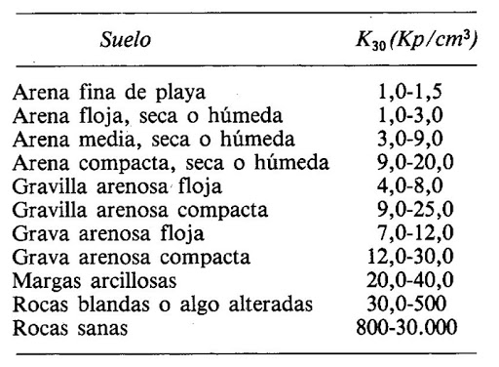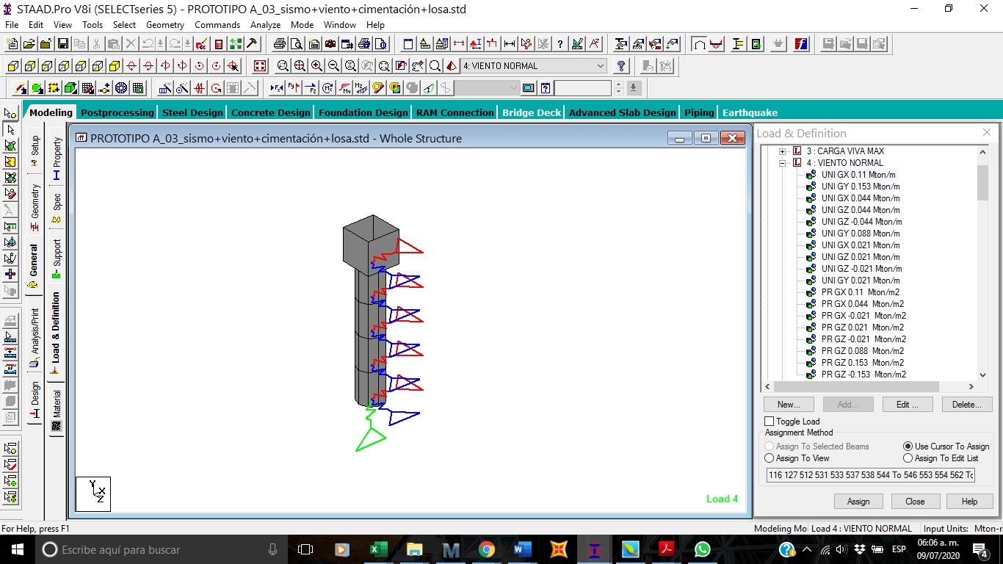

***Figura 21. Resortes K equivalentes al módulo de reacción.***



**PROPIEDADES DE MADERA**



**Viga 20x25 cm**

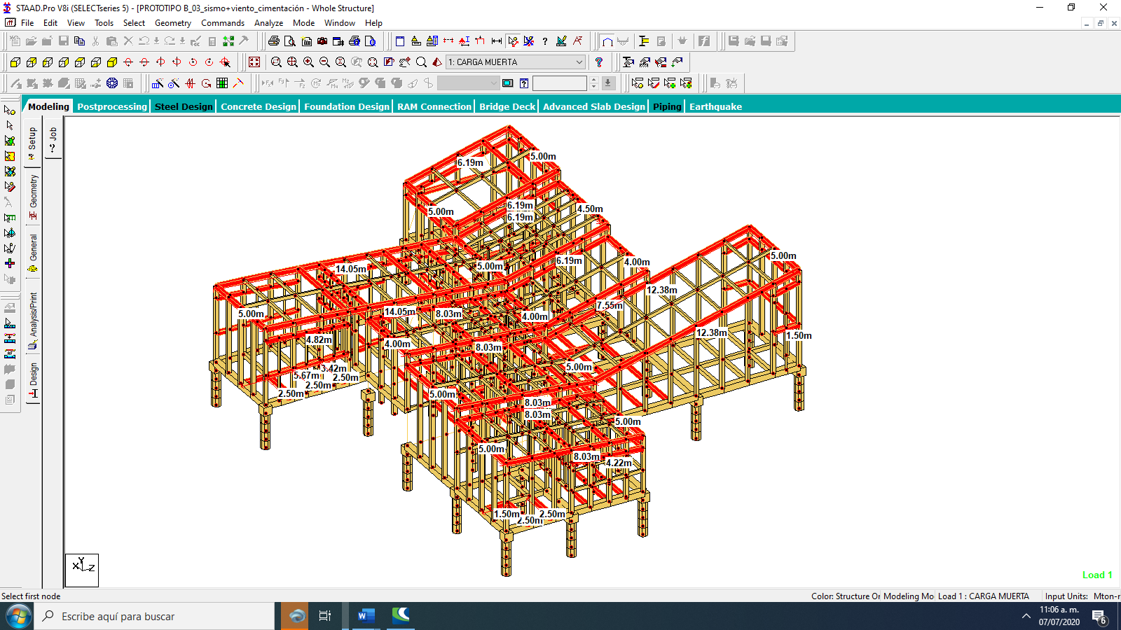

***Figura 14. Isométrico de vigas de sección 25x20cm vista general***

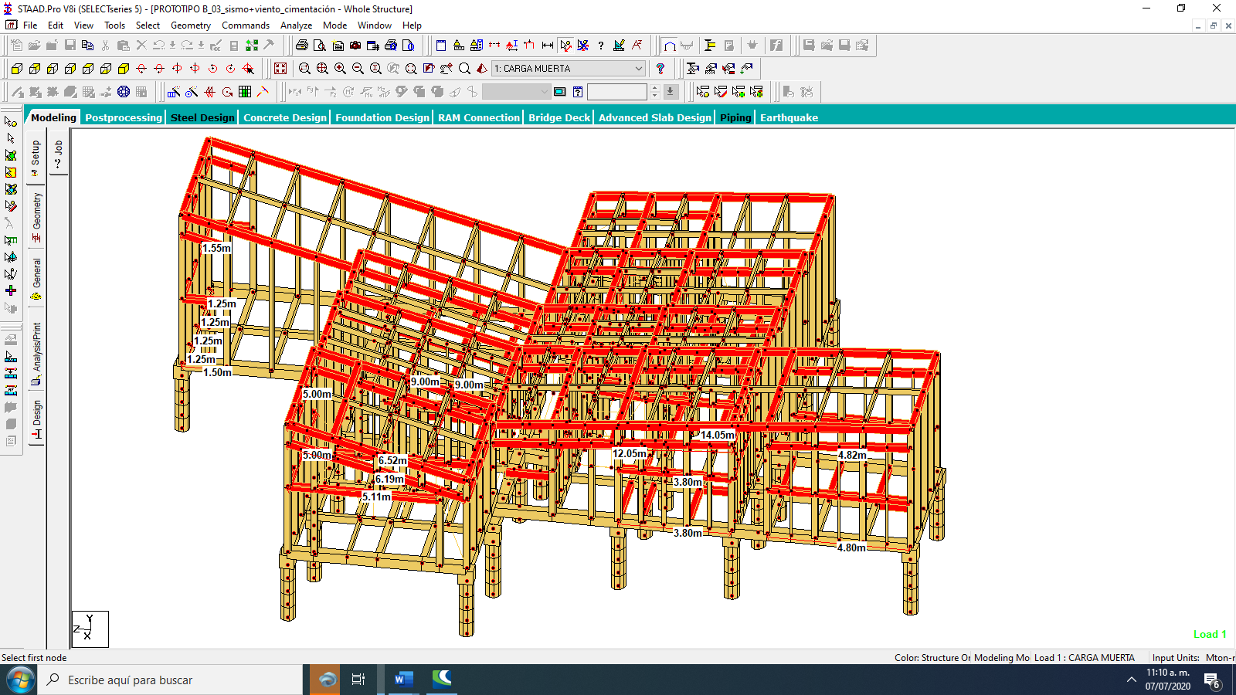

***Figura 14. Isométrico de vigas de sección 25x20cm vista trasera***

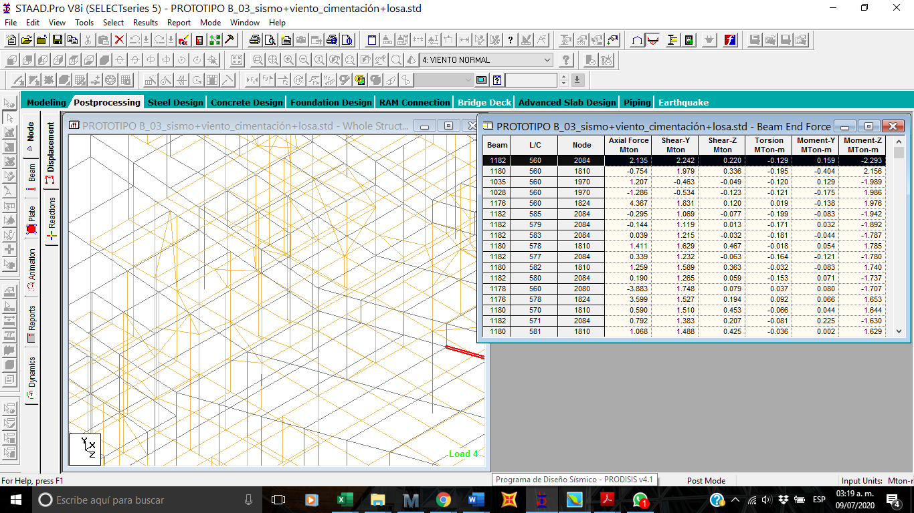







**Viga 10x25**

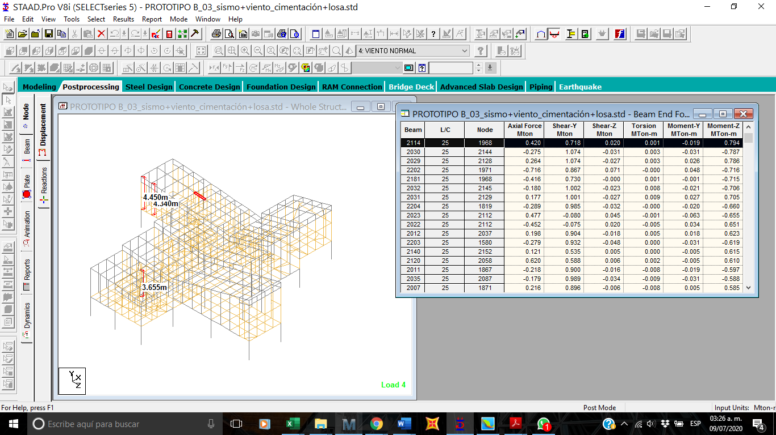







**Columna 20x20**

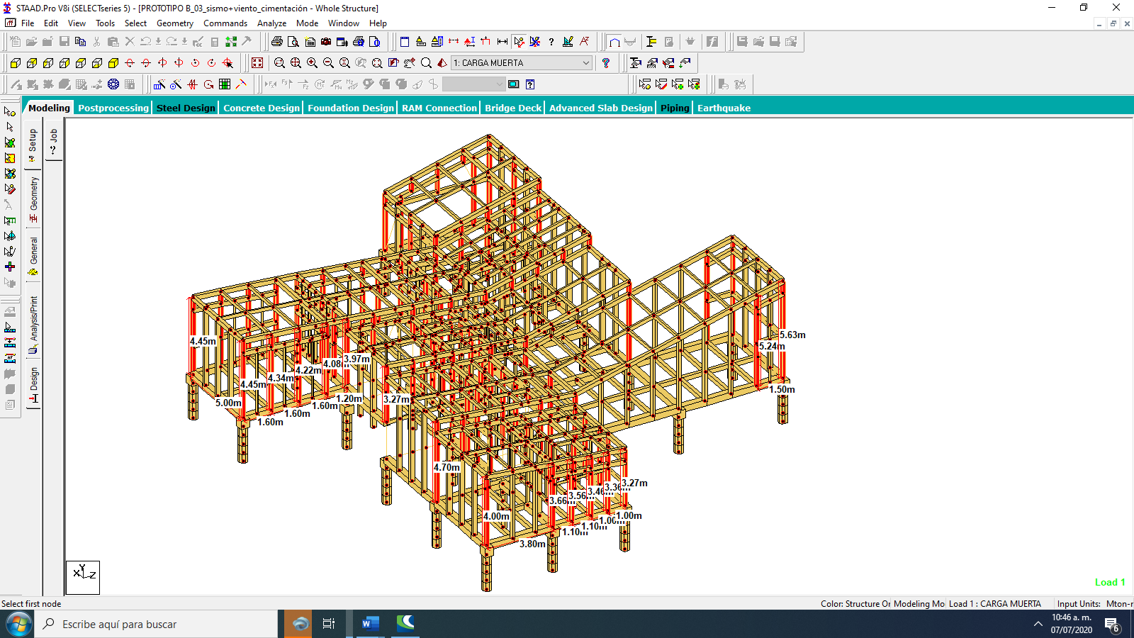

***Figura 10. Isométrico de columnas de sección 20x20cm vista general***

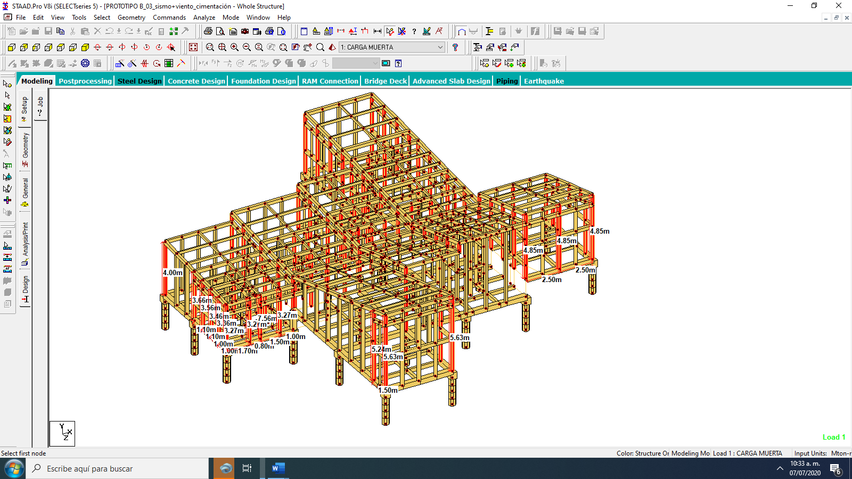

***Figura 11. Isométrico de columnas de sección 20x20cm vista lateral***

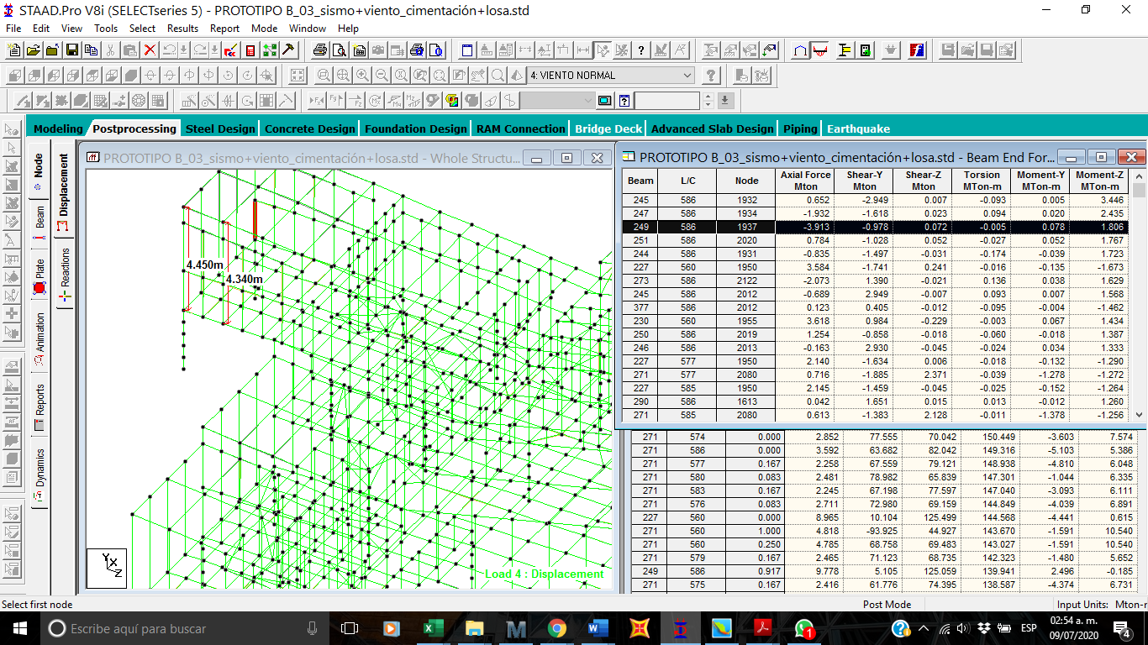





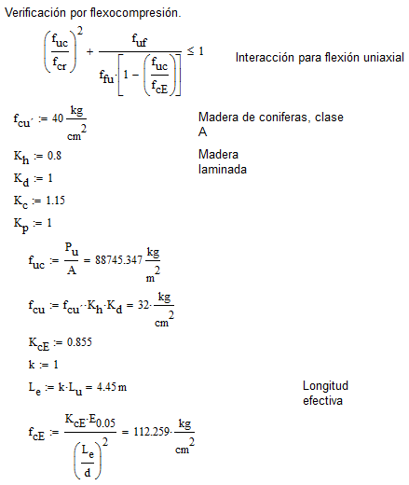



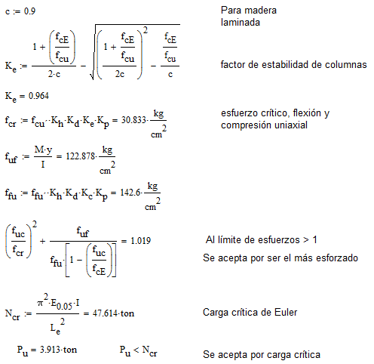

**Columna 15x25**

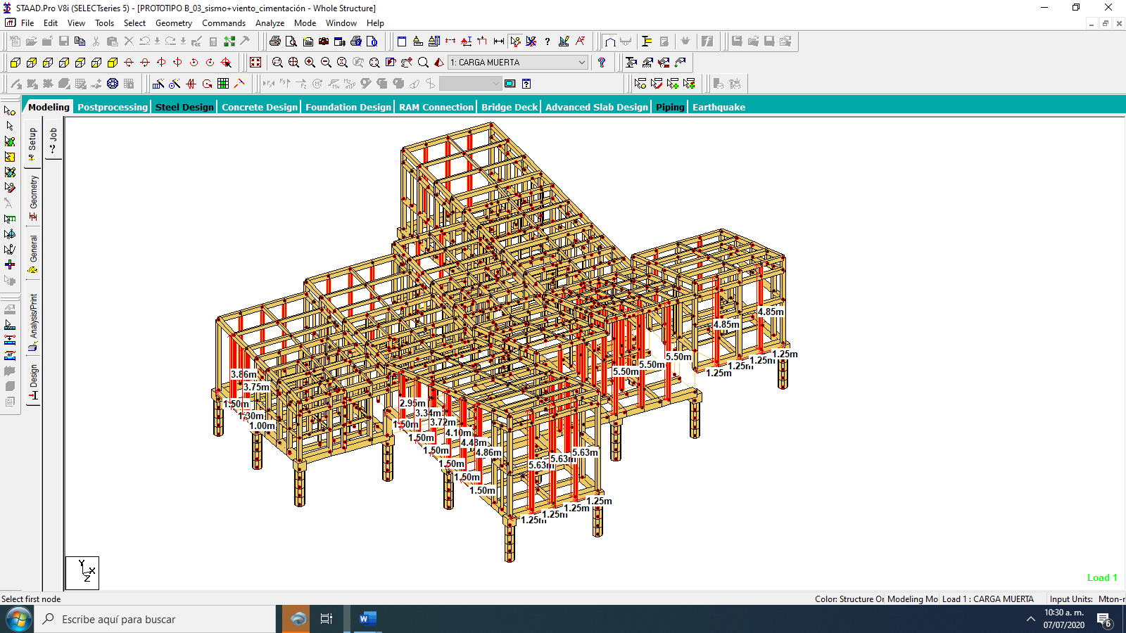

***Figura 15. Isométrico de columnas de sección 25x15cm vista general.***

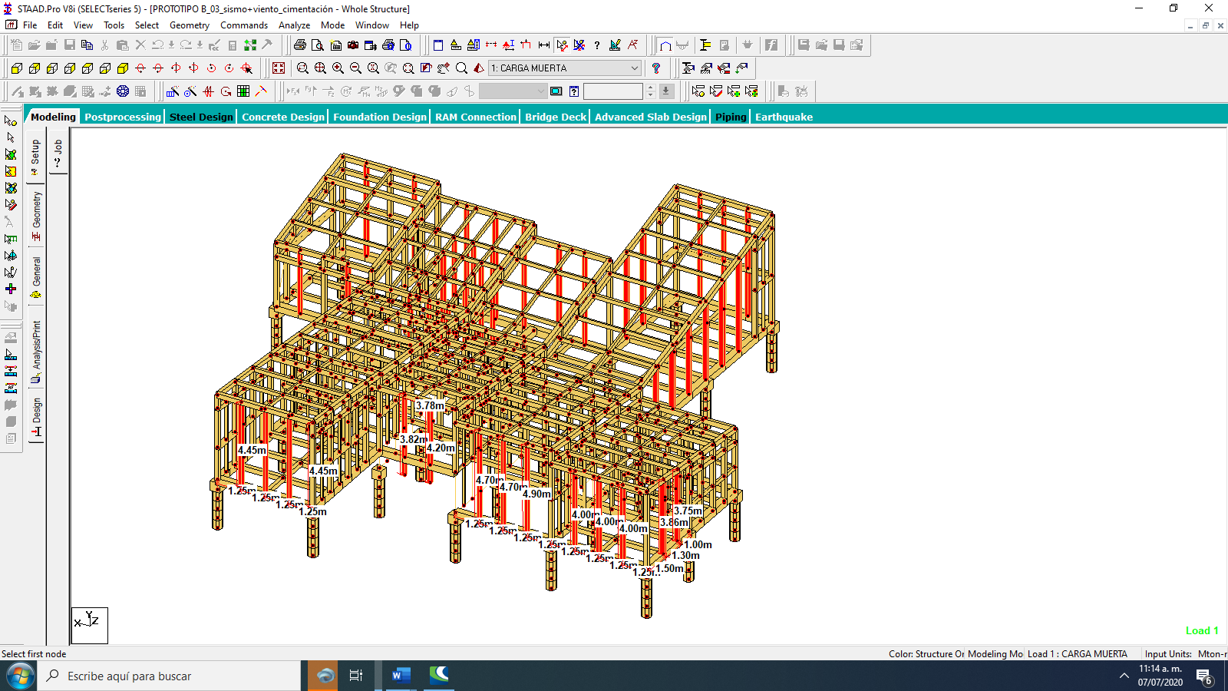

***Figura 16. Isométrico de columnas de sección 25x15cm vista lateral***

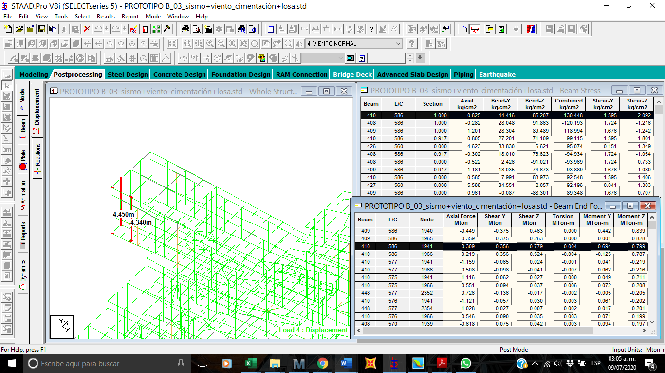

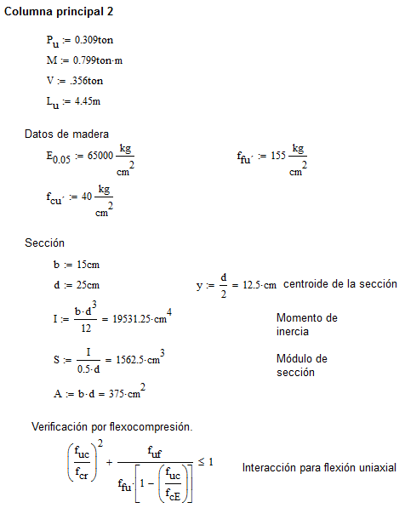

 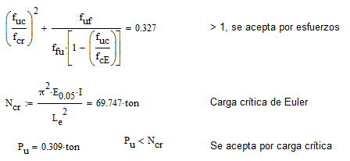

**Columna 15x15**

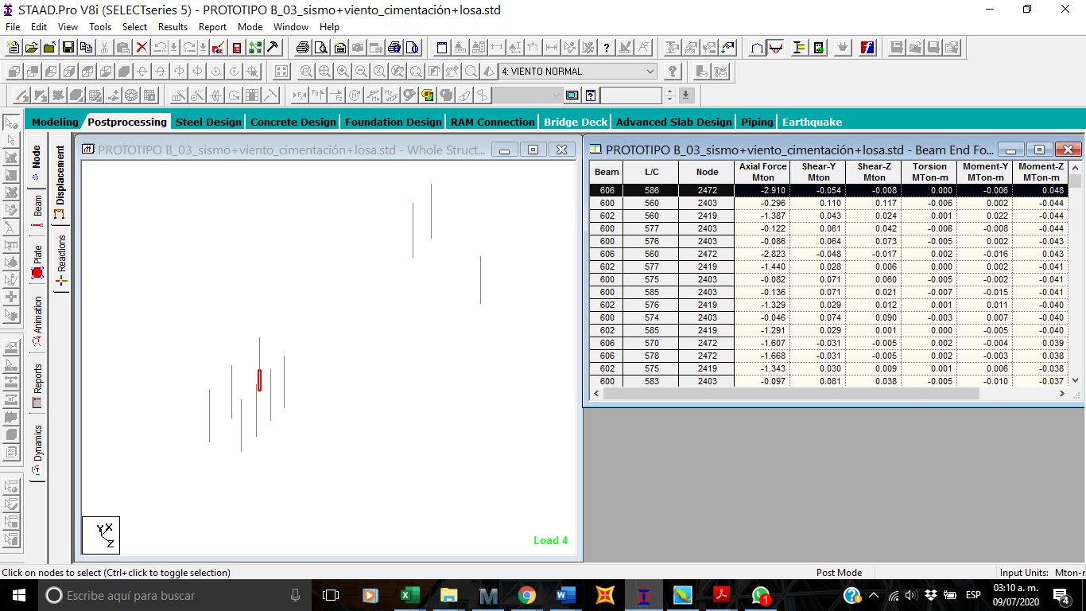

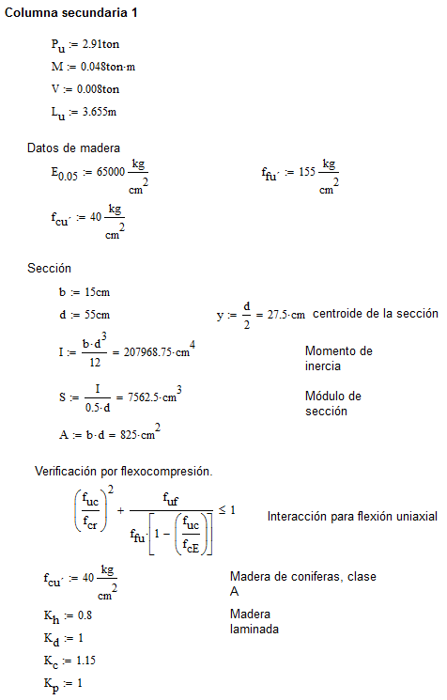



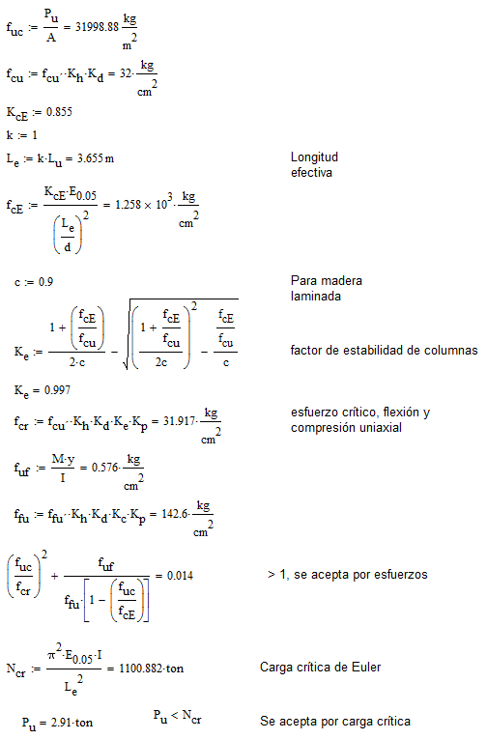

  
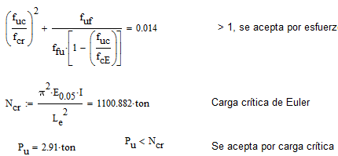

**COLUMNA 5X15**

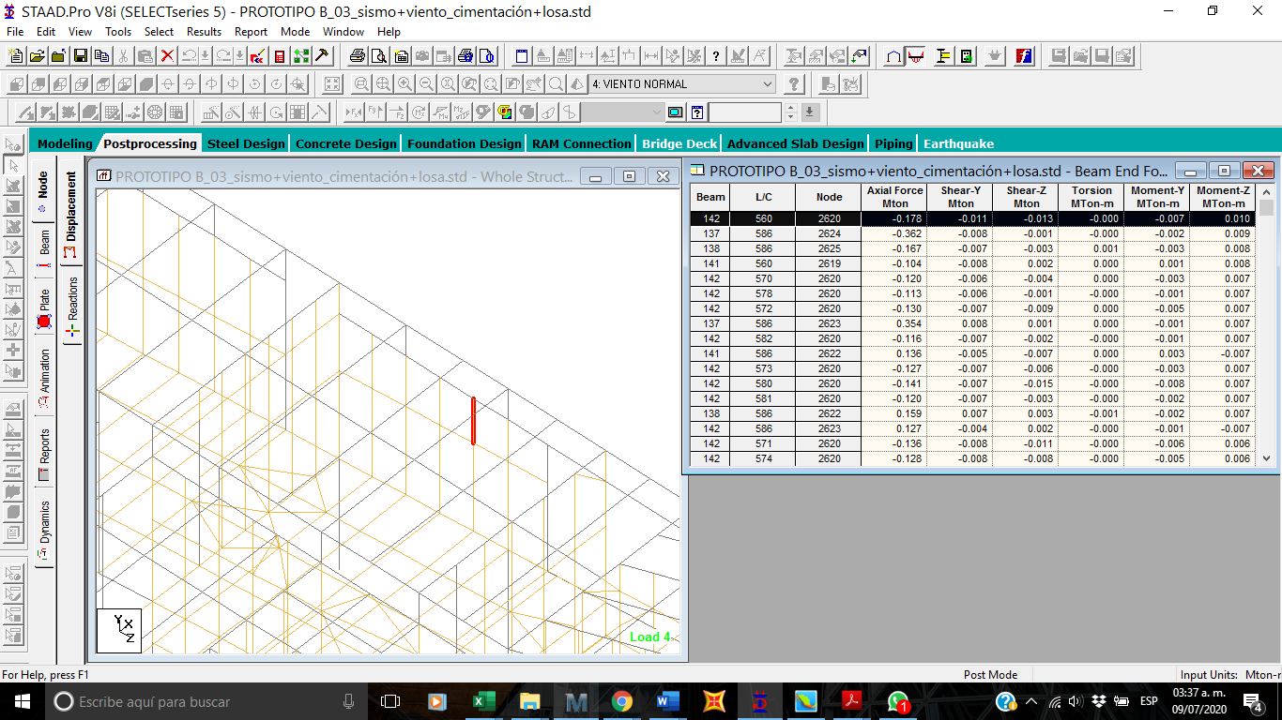

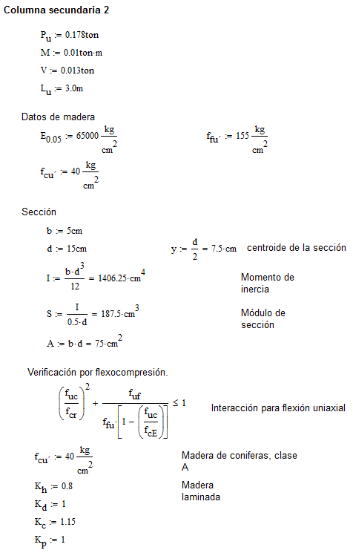



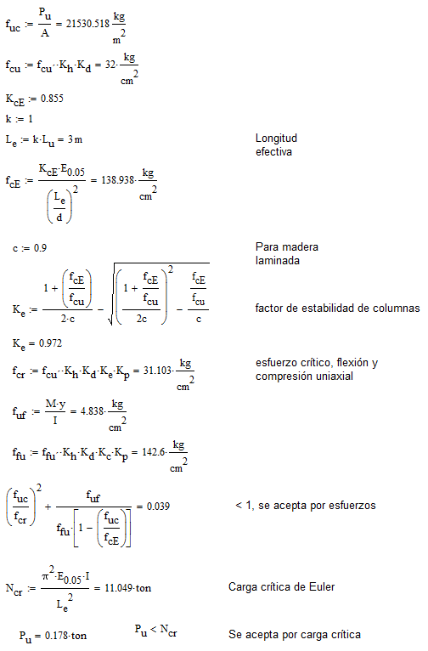



**Ing. Germán González Sánchez  
Cedula profesional: 5880742**